THE KENTUCKY ONLINE PERMITTING PORTAL
  - Using the KY DHBC Portal
Contents
You can go a Topic in the Index below, Click on it while holding down the Ctrl Button and you will be moved directly to that Section
1. Introduction 3
Using this Help Document 3
2. Getting Started-All Users 3
Navigating the Site-All Users 4
System Registration- All Contractor Users 6
System Registration- Homeowners Only 7
3. Log On-All Users 9
Log On 9
Forget Your Password-All Users 11
4. Log Off- All Users 12
5. Viewing Permits and Applications-All Users 12
View My Permits and Applications-All Users 12
Icon Legend and Use- All Users 12
Edits-All Users 13
Payments-All Users 13
6. View My Licenses-All Contractor Users 14
Contractor Licenses 14
7. Entering Applications-All Users 15
Navigating the Tabs –All Users 15
Entering a Permit Application for HVAC 15
The Contractor Tab-HVAC 17
The Applicant Tab-HVAC 20
The Location Tab-HVAC 25
The Owner Tab-HVAC 27
The Permit Tab-HVAC 28
The Summary Tab-HVAC 33
Entering Permit Applications for Plumbing 35
The Contractor Tab-Plumbing 37
The Applicant Tab-Plumbing 40
The Location Tab-Plumbing 45
The Owner Tab-Plumbing 48
The Permit Tab-Plumbing 51
The Summary Tab-Plumbing 55
Entering an Application for a Medical Gas Permit-Plumbing 57
The Contractor Tab- Medical Gas Permit Applications 58
The Applicant Tab- Medical Gas Permit Applications-Plumbing 60
The Location Tab- Medical Gas Permit Applications-Plumbing 65
The Owner Tab - Medical Gas Permit Applications-Plumbing 68
The Permit Tab - Medical Gas Permit Applications-Plumbing 71
The Summary Tab-Medical Gas Permit Applications-Plumbing 72
8. Homeowners Entering Plumbing Permit Applications 75
Beginning the Application Process 75
Homeowner Location information 77
The Homeowner Owner Tab 78
The Homeowner Permits Tab 79
The Homeowner Summary Page 82
9. Check Out and Payment –All Users 83
10. Search KY State Licenses-All Users 90
11. Search KY State Permits-All Users 93
12. Search KY State Plan Reviews-All Users 97
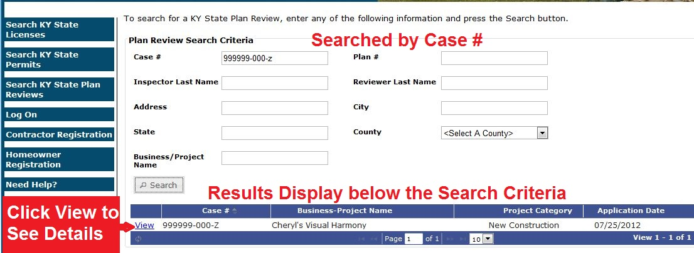 98
13. Transfer a Permit-Plumbing 98
14. Request a Refund-Plumbing 100

Introduction
The Kentucky (KY) DHBC Portal allows Licensed Contractors from the regulated trades (e.g. HVAC, Plumbing) to submit permit applications, make payment for permits, and view their permits and applications that are in the system. All Users can search for KY State Licenses, KY State Permits and KY State Plan Reviews, but only licensed contractors are able to register and use the system for the purpose of permit applications.
The KY DHBC Portal is designed to provide registered users with the online tools they need to manage their permit applications. Each user within a trade has a role and permissions that automatically display the Menu Options, Pages and Forms that are specific to their work area. HVAC Contractors have some different menu choices the Left Side Navigation Menu than Plumbing Contractors. However, registration, logon, navigation, payments and license and permit searches are the same for all contractors. This document will identify those common portal pages as well as provide trade-specific instructions to assist the various specialty Contractors in using the system.

Using this Help Document
The KY Portal is designed to work similarly for all users. The navigation of each page, types of links and link uses are generally the same as you move from one page to the next or one tab to the next. Some things to keep in mind are:
- The Common help pages are identified as All Users or All Users-Contractors
- Trade specific pages will be identified as Plumbing or HVAC.
- Your role and permissions will determine which features are available for your use.
- Every attempt is made to insure that the screen shot figures in this help document match what you see on your computer screen. However, system improvements are on-going and slight variations are possible.

Getting Started-All Users
- OPEN Internet Explorer and type https://ky.joportal.com/ in the address field.
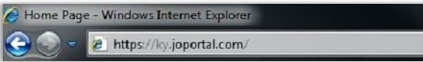
- The Portal supports three different web browsers; Google Chrome, Mozilla Foxfire, and MS Internet Explorer 8 or newer. If you need a browser or need to update a browser, use the links at the bottom of the Home Page to open a new window and download the free software.
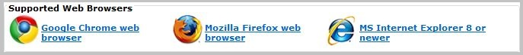
- Adobe Acrobat Reader is required to open some documents. If you need Adobe Acrobat Reader or want to update the version on your computer, click on the link at the bottom of the left side menu
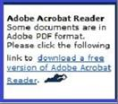

Navigating the Site-All Users
The Kentucky Department of Housing, Buildings and Construction (KY DHBC) contains links to other related Kentucky government web sites. These links are found in the submenu at the top of the page. Portal Pages are displayed in the left side menu. Contact information for the KY DHBC and its specific divisions is also listed on the left side menu below the Portal Pages. The next figure explains the layout of the home page.
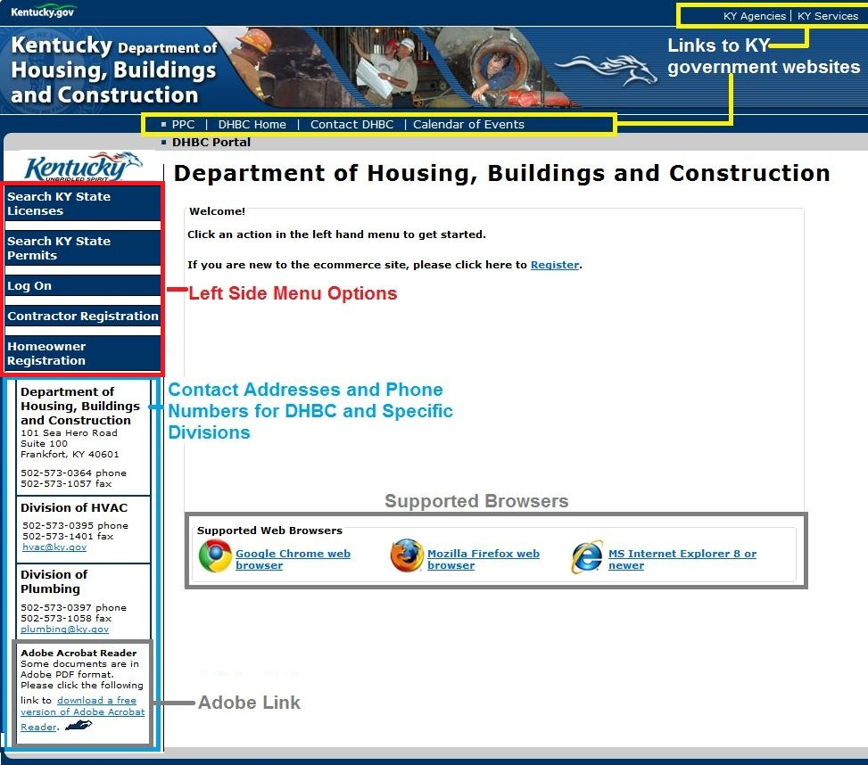

System Registration- All Contractor Users
Kentucky Users currently registered in JO-BCE do not need to re-register to use the Portal. For information on the Log On page please see the next section. All contractors with a license and ID number (last 6 of the Social Security Account number) on file with the State of Kentucky are eligible to register to use the Portal.
Persons not currently registered in JO-BCE must create an account to access the Portal. To create an account the following information is required:
- A valid email account. NOTE: The system does not allow multiple registrations for an email address or Contractor License/SSN combination.
- The Contractor license number that has been registered with the State of Kentucky.
- The ID Number ( last 6 of the SSAN) for the Contractor’s license
To register, follow the steps below.
- Click either the Register Link on the Form or the Register Button in the left hand menu.
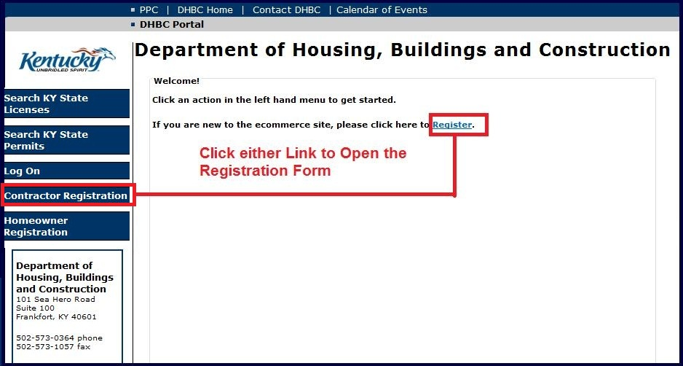
- The Registration Form opens. All information fields are required to be filled out.
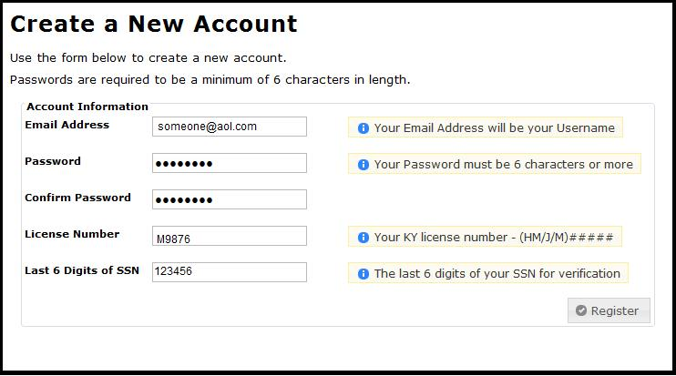
- When finished, please click on the Register Button on the right.
- If you cannot register because the system cannot validate your license number or the last six digits of your SSN, please contact the DHBC (502-573-0364) for assistance.

System Registration- Homeowners Only
Members of the Public can search permits and licenses without registering in the system. However, homeowners wishing to apply for a plumbing permit through the DHBC Portal must register in the system by doing the following:
- Click either the Register Link on the Form or the Register Button in the left hand menu.
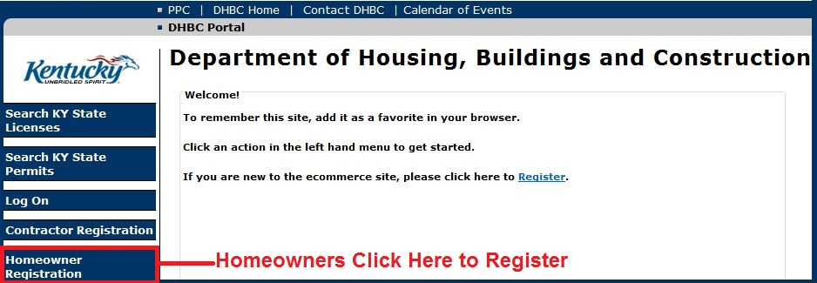
- The Registration Form opens. All information fields are required to be filled out.
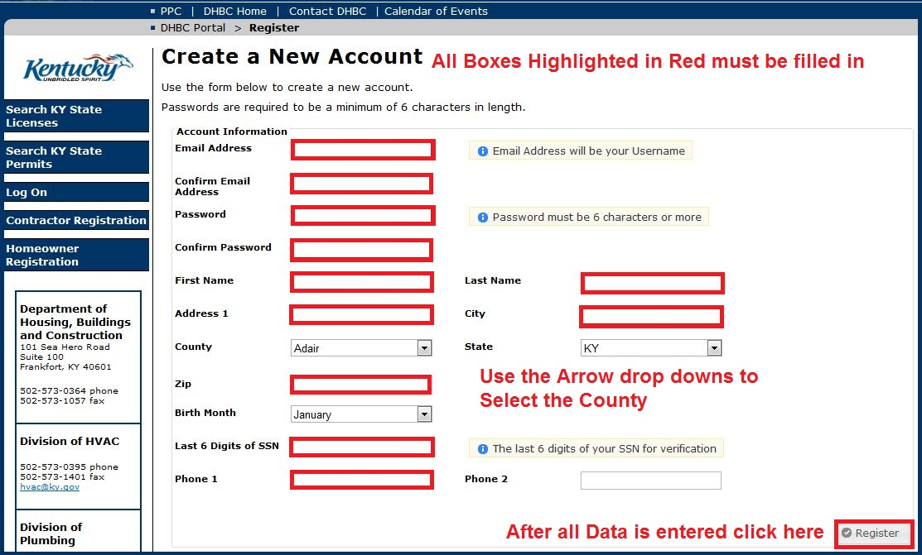
- When finished, please click on the Register Button on the right.
- For more information on homeowners entering permits please see Section 8-Homeowners Entering Permit Applications

Log On-All Users
Once registered with JO-BCE users can login to the system. Steps for logging in and how to use the system are in the following sections.

Log On
- All Users Registered in the System will log on from the main DHBC Portal page by selecting Log On button from the Left Side Navigation Menu.
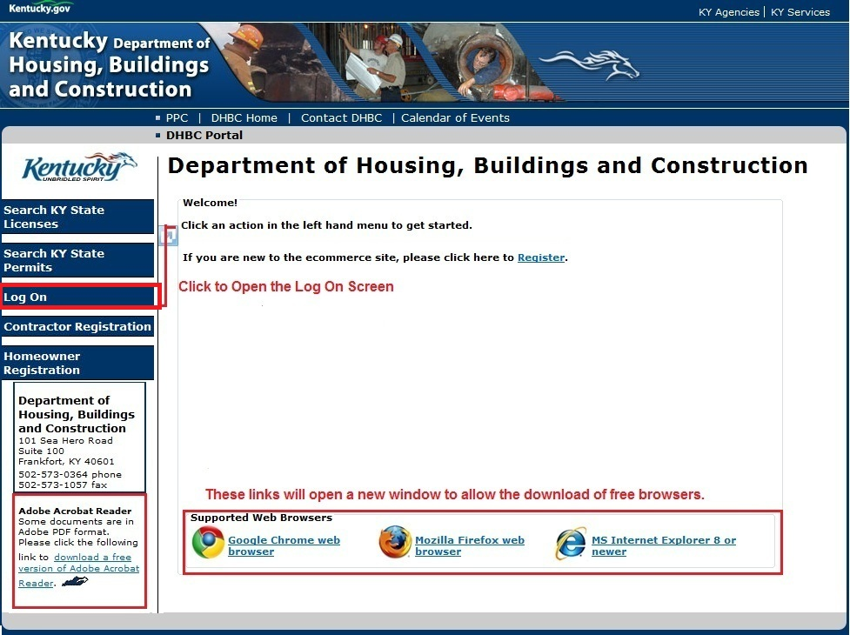
- The Log On screen opens.
- Type in your user name (e.g. some.one@ky.gov) and password (mypass) and Click the Log On button.
- If you consistently use the same computer to access the KY DBHC Portal, you may want to click the Check Box for Remember Me? to allow the system to recognize you and display your user name at the next log on. This step is optional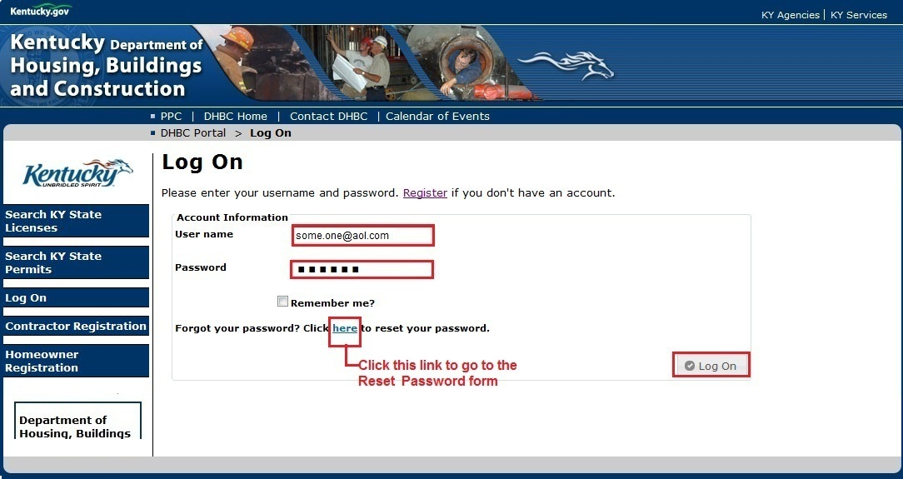

Forget Your Password-All Users
If you have forgotten your password,
- Click on the word here to open the Reset Password form
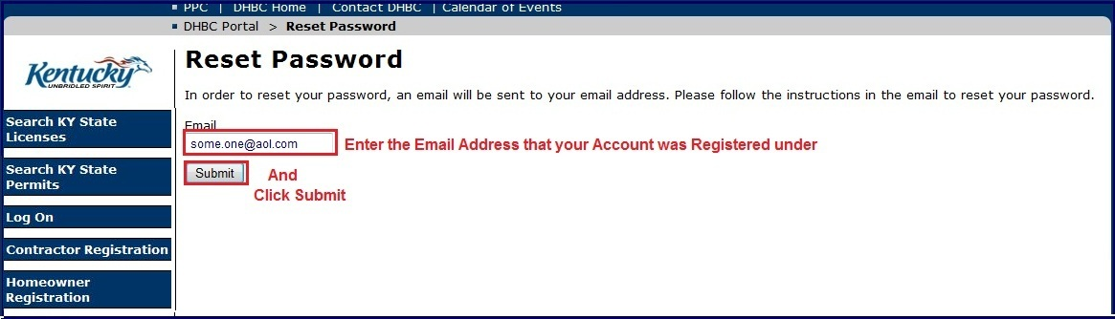
- Check your email account for the instructions to reset your password.

Log Off- All Users
Internet security is of upmost importance. To ensure that your connection to the KY DHBC Portal is closed always log off of the system at the end of your work session. Just click the
Log Off button found at the bottom of the Left Side Navigation Menu.

Viewing Permits and Applications-All Users

View My Permits and Applications-All Users
This is the first page that appears once logged on. The section titles are specific to the trade for which you are licensed and the roles and permissions associated with your login.
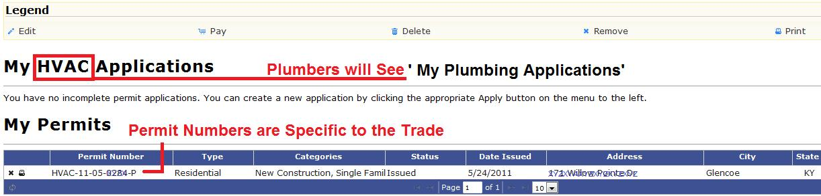
This page shows your current applications and permits. You can return to this page at any time by clicking the View My Permits button from the Left Side Navigation Menu. Also available at any time are the Search for KY Licenses and Search for KY Permits. To apply for a permit, see the section on Entering a HVAC Permit Application, Entering a Permit Application for Plumbing or Entering an Application for a Medical Gas Permit-Plumbing

Icon Legend and Use- All Users
The icon legend is location across the top of the page in the light tan section.
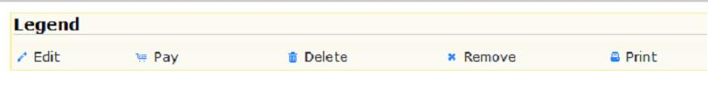
- Edit (pencil) an Application to add new, different or missing information in order to complete the Permit Application process.
- Delete (trash can) incomplete Applications or Applications no longer required. This action deletes the record from the system
- Remove (X) a permit or application record. This removes the record from your view, but does not delete it from the system.
- Pay (shopping cart) for one or more applications (if the data is complete) to make a single payment. See the Payments section for more information.
- Print (printer)a copy of a permit or application
- The icons that are available to a specific record appear to the left of the record in the permit or application grid.
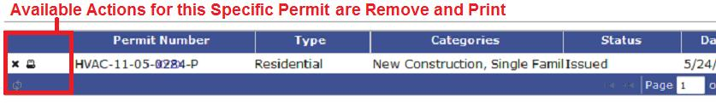

Edits-All Users
To edit an application record, click on the blue pencil to the left of the Application that you wish to edit/complete. This will open the Application form and fill in the information that has already been entered into the system. For more information on editing applications see the sections on entering Permits for your trade group.

Payments-All Users
Payments can be made for an individual application or for multiple applications.
- To pay for a single permit application, click the Pay Icon (shopping cart) to the left of the specific application.
- To pay for multiple permit applications, place a check in the Check box to the right of each Permit Application for which you wish to combine payment. Then Click the Pay Icon (shopping cart) located beneath the grid.
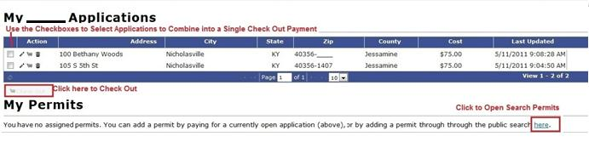
- Click the Check Out button to open the Check Out Summary page. From the Check Out page your payment process will complete the same way payment for a single permit does.
- For more information on making payments please see Section 7-Check Out and Payment

View My Licenses-All Contractor Users

Contractor Licenses
Contractors can use the button on the Left Side Navigation Menu to review the status of their licenses with the State of Kentucky.
- Click on the View My Licenses button you will see a “Processing” message. It may take a few seconds for the system to return your license information.
- The page will display as shown below:
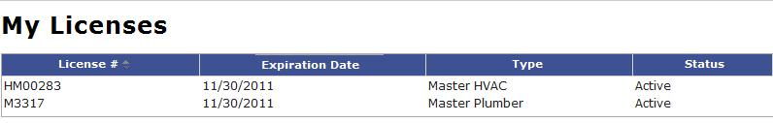

- For more information on searching for or viewing licenses see Section 9 Search KY State Licenses.

Entering Applications-All Users

Navigating the Tabs –All Users
The permit application is made up of 6 different tabs; Contractor, Applicant, Location, Owner, Permit and Summary. Tabs are designed to reduce entry time by allowing you to select previously entered data, validate address information against US Post office records and display fields that are appropriate based on the type of project work where a permit is required.
Once you begin the Permit Application process, the system will record all of the data entered into the system even if you do not complete the application. If you begin an application and do not complete the application you will be able to view, edit or delete the application through the View My Permits page. This process is described in Section 5 View My Permits and Applications.

Entering a Permit Application for HVAC
After logging in the system, additional choices are displayed in the Left Side Navigation Menu. Your choices are available based on your current license status. If you are a Master Contractor with an Active license you will see all of choices shown below. If you are not a Master Contractor or your license is in any status but Active you will not see the Apply for an HVAC Permit choice.
- Select Apply for HVAC Permit at the top of the Left Side Navigation Menu
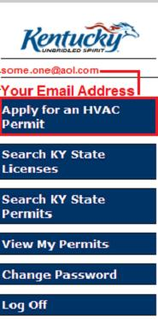
- Before starting the Permit Application Process it is important to read and follow the directions in the Notice of Local Jurisdictions with Permitting Offices at the top of the Apply for an HVAC Permit form. The Notice reads as follows:
Notice of Local Jurisdictions with Permitting Offices
Permits for all HVAC projects are issued either by Kentucky Division HVAC or the Local Jurisdiction Authority. Below is a list of HVAC project types falling solely under State permitting authority. For all other HVAC projects, Please click here for a list of the Jurisdictions and contact information under Local Authority for the issue of HVAC permits.
Kentucky Division HVAC Permits are required in all Jurisdictions for the following project types:
- State owned or State leased facilities
- Institutional buildings, educational facilities and related buildings
- All buildings required to be licensed by the Cabinet for Health Services or the Cabinet for Families such as hospitals, day care centers, nursing homes, group homes and other similar facilities.
- High hazard occupancies
- Industrialized building systems except for the on-site placement and assembly of modular homes

- All HVAC projects in the State of Kentucky require a permit and it is necessary to check the list of Local Jurisdictions to ensure that the application is made to the proper authority. To view the list of Local Jurisdictions with Permitting Offices Click the link “Here”
- If the location of the project is in one of the Local Jurisdiction Permit Authority and it is not a project type that requires a Kentucky State Division HVAC permit you will need contact the Local Permitting Authority to make an application. Do not continue with the online application process.
- In all other cases, the Kentucky State Division HVAC is the permitting authority and you should continue with the online application.

The Contractor Tab-HVAC
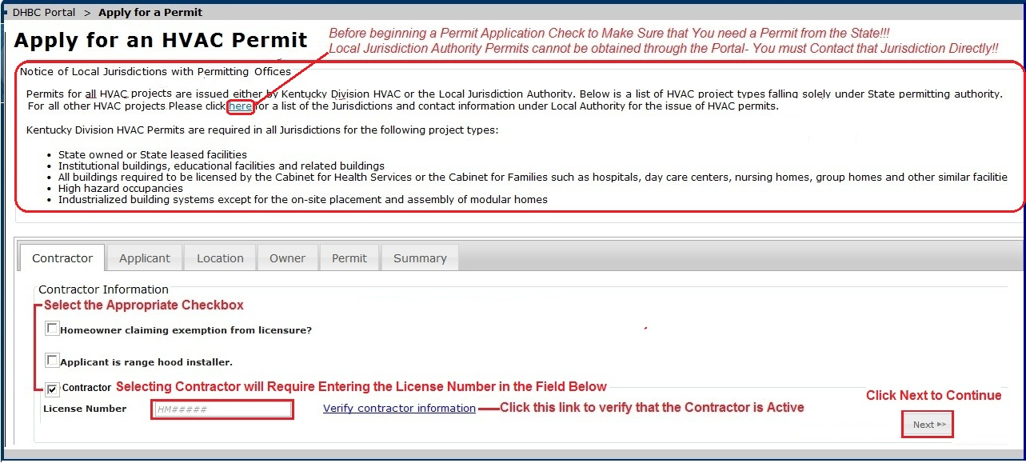
- There are three Checkbox options on the Contractor tab, Homeowners, Range Hood Installers and Contractors. Only one can be selected.
- If Homeowner claiming exemption or Range Hood Installer is chosen, click the Next button at the bottom right of the page to continue or select the Applicant Tab by clicking on Applicant at the top of the form.
- Contractor Permit Applications are made in the license number of the Master Contractor for the project and the license must be in an active status. The following are users that can enter a permit application using the Master Contractor’s license number:
- A KY DHBC internal user enters an permit application into the system for the Master Contractor
- A person with system access; who is an employee of the Master Contractor on the project; enters the permit application for the project
- The Master Contractor him/herself enters the permit application
  - Master Contractors who are logged into the system will have their information displayed automatically on the contractor tab.
  - Enter the Master Contractor License # and click on Verify Contractor Information. Information about the contractor, including addresses and license status displays under the License Number field.
Note – it is the responsibility of the person entering the permit on behalf of a contractor to ensure that the Master Contractor License is Active and valid and that all other requirements are met. If this is not the case, the process should be terminated until the Master Contractor license data and information is satisfied by the HVAC division.
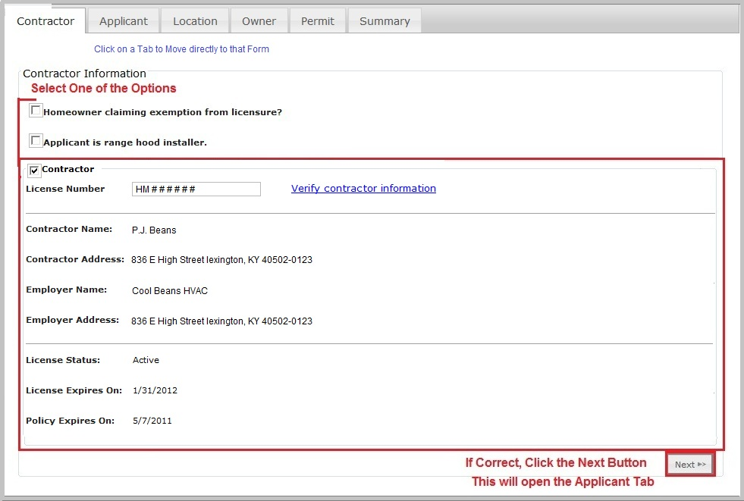
- After the contractor is verified, Click the Next button or Click on the Applicant Tab at the top of the form

The Applicant Tab-HVAC
- If either the Contractor or Contractor’s Employer is the Applicant, select the appropriate checkbox and click Next or click on the Location Tab at the top of the form. The applicant information for this application will be taken from the Contractor information already stored in the system.
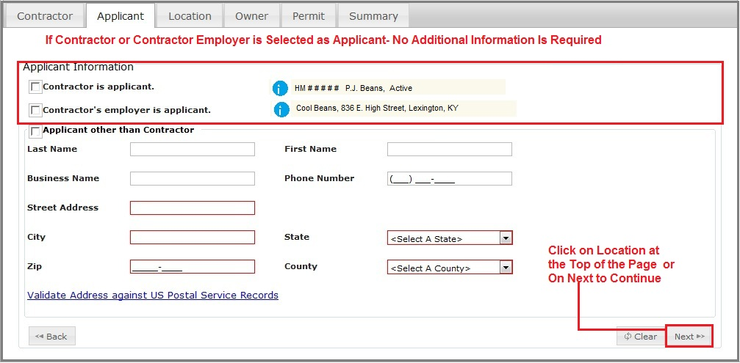
- If the Contractor is not the Applicant, check the Applicant other Than Contractor box and fill in the one of the following:
  - Enter the Last Name and press Enter. The system has an automatic search feature based on the Last Name, and will return all records found with a matching Last Name. This will help reduce the amount of data entry.
  - If the Applicant is a business, fill in the section for the Business Name and press Enter. The system also does an automatic search based on the Business name.
- If there are no matches by Last Names or Business Names, no grid will display. The search will display the first 10 records. If more than 10 records are found, the number of records is displayed at the bottom right of the grid. If more than one page of records is found, you can use the right and left arrows to move through the pages to locate the desired record. NOTE: The arrows have been highlighted in red in the following figure. The arrows will be light gray on the bottom of the grid.
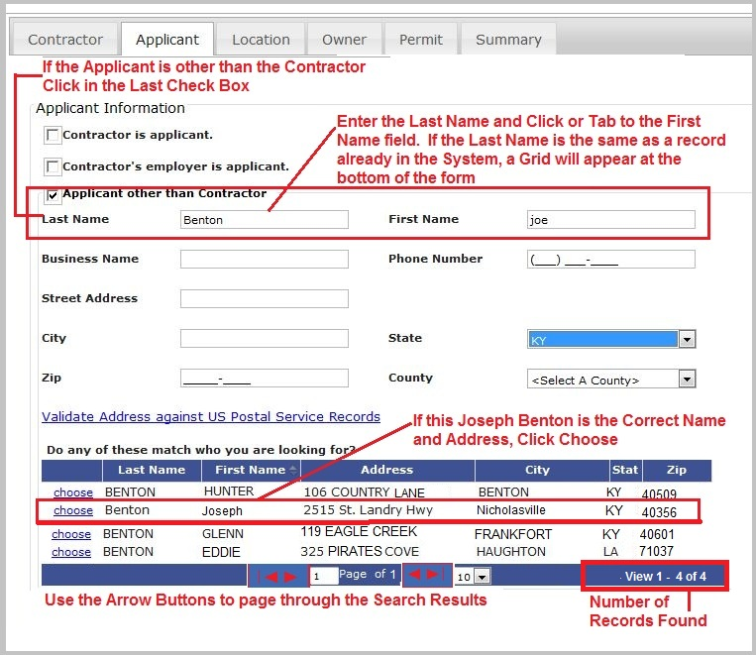
- If you determine that there is an identical record (Last Name, First Name, Address, City State and Zip) or (Business Name, Address, City, State and Zip) in the search results, click on the link Choose to the left of the record. The information will populate the form fields and the grid disappears as shown below. If the information is correct, click Next to continue. It is not necessary to validate an existing record and address against the US Postal Service Records. The system will use this data for the permit application.
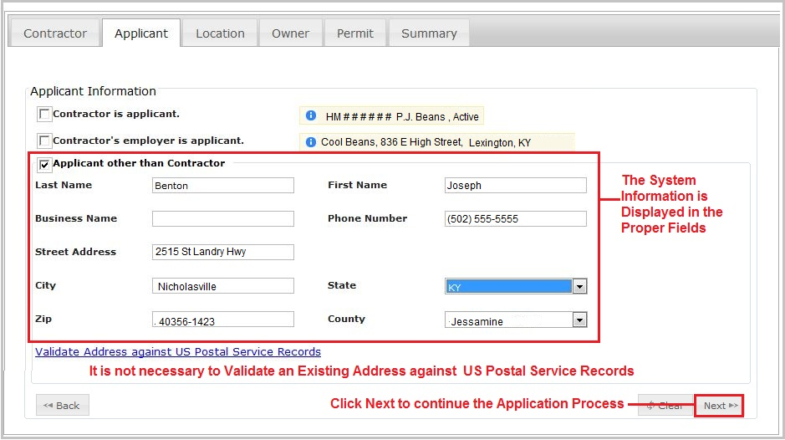
- If searching for the Last Name or Business Name did not produce any matching records, it will be necessary to enter data into the Applicant form. This new information will be used for this Permit Application and stored in the system for future reference.
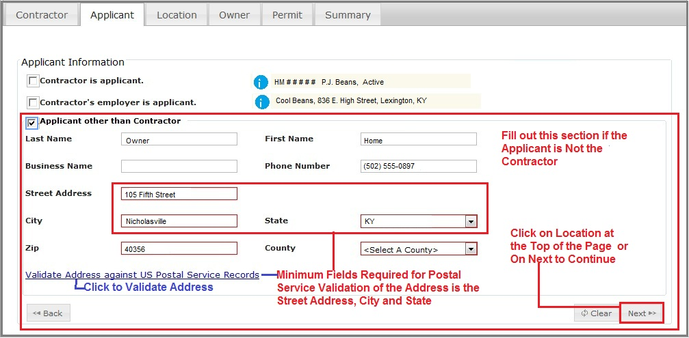
- The Street Address, City and State must be filled in to use the US Postal Service validation link. After entering the information for these three fields, Click on the Validate Address against US Postal Service Records link on the screen and the form expands to display the standardized address
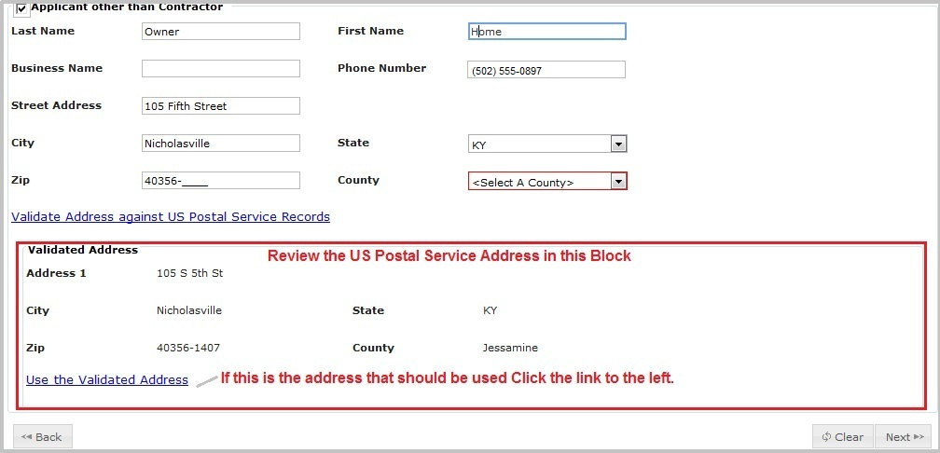
- Once you have determined that the Validated Address is the correct one to use, click on the Use the Validated Address link. This will update the fields in the Applicant form and hide the validated address box as shown below.
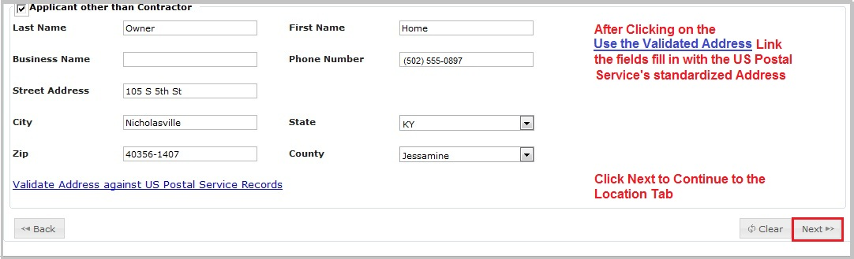
- Click Next to continue to the Location tab.

The Location Tab-HVAC
The Location tab is where information about the project location is entered. To assist you in using this tab there are Instructions at the top of the tab as shown in the next figure. These instructions are displayed on the form whenever the tab is opened.
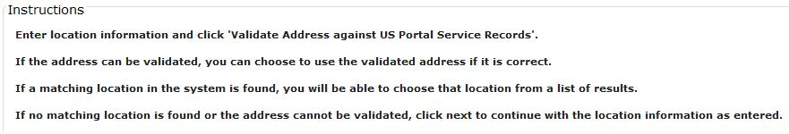
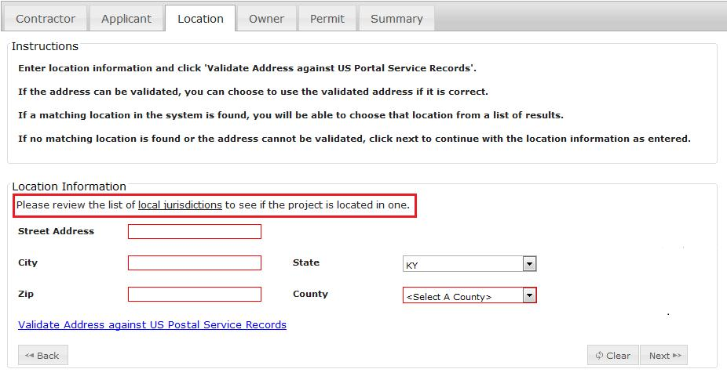

- Enter the street address, city, state and zip for the location where the HVAC project will be done.
- Use the Validate Address against US Postal Service Records link the Street Address, City and State; this is a required step.
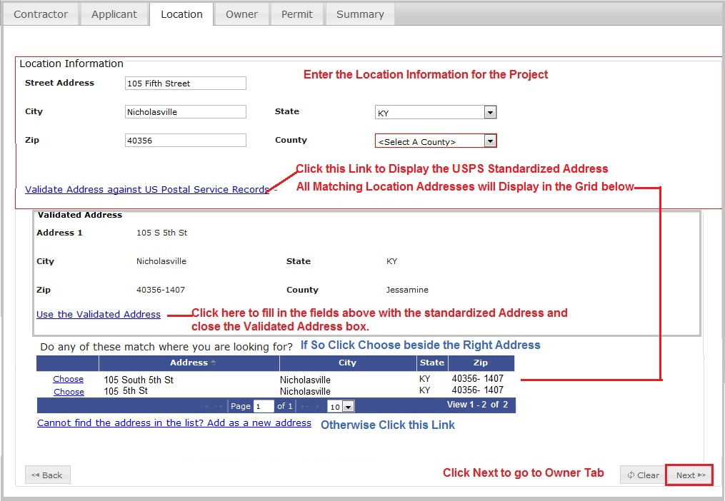
- Review the matching records and determine if there is a match to the location address that you want to enter into the system for this permit. If so, click on the Choose link to the left of the correct address.
- You if you want to use the USPS Validated address just click on the Use the Validated Address and this will update the fields in the Applicant form and hide the validated address box.
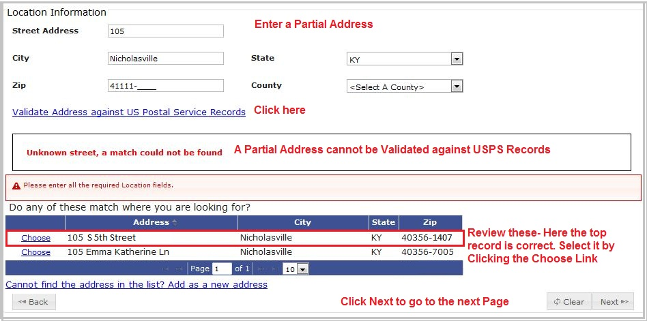
If the address cannot be standardized, an error message will display relating the type of error. New construction locations are particularly prone to error, as the Postal Service may not have those locations on record. If the address is not in the list, click on the Cannot find the Address in the list? Add as a new address link.
- Don’t Remember the Exact Address or Spelling? You can enter a partial Street Address and the system will attempt to find a matching record as shown above. If the address is not in the list, click on the Cannot find the Address in the list? Add as a new address link.
- Once the location Address fields have been filled, click on Next or the Owner tab to continue the Permit Application.

The Owner Tab-HVAC
This tab records the Owner information for the permit. There are three options.
- Click the appropriate checkbox. If the Applicant is the Owner is checked no further information is needed; click Next to continue
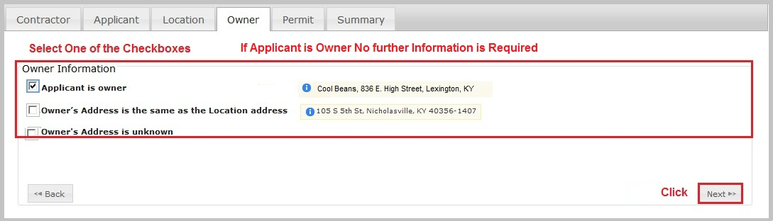
- If the Owner’s Address is the same as the Location Address or the Owner’s Address is unknown is selected, additional information is required. Enter the Business name and Phone number or the Last Name, First Name and Phone number of the owner. This information is required to continue to the Permit tab.
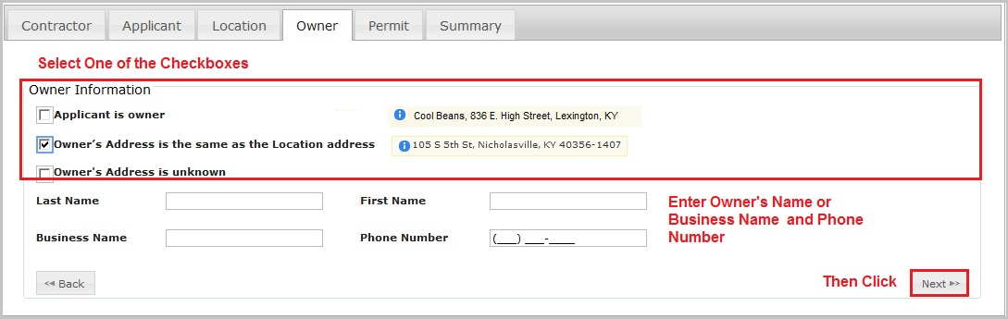
- Once the selection is made and any necessary information filled in, click Next to continue to the Permit tab.

The Permit Tab-HVAC
- From the Type drop down – indicate if this is a Commercial or Residential Permit. Additional information fields will display specific to the Permit type selected.
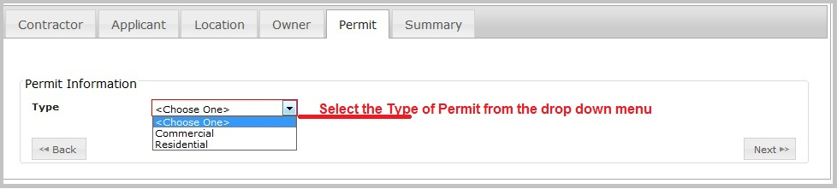
- For Commercial permits: Click on the drop down arrow to the right of the Categories box. A menu of the possible types of commercial permits will display with Checkboxes to the left of each type.
- Types include: Existing Unit, Multi-family Unit, New Construction and Range Hood. Choose all that apply from the Categories menu.
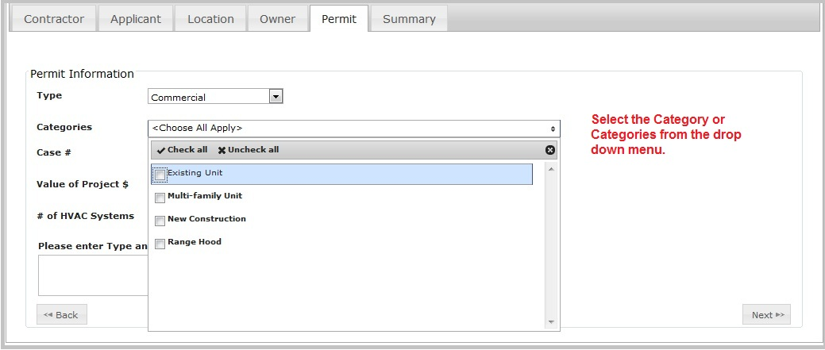
- Enter the additional information about this project. Depending on the Permit, different fields will highlight in red to indicate the required fields. The Value of the Project is a required field for commercial permits for all Commercial HVAC projects with the exception of the Multi-family Unit Category. If Multiple Family Unit is selected, the number and type of HVAC systems must be included. The type and equipment size for the units should be entered into the comment box.

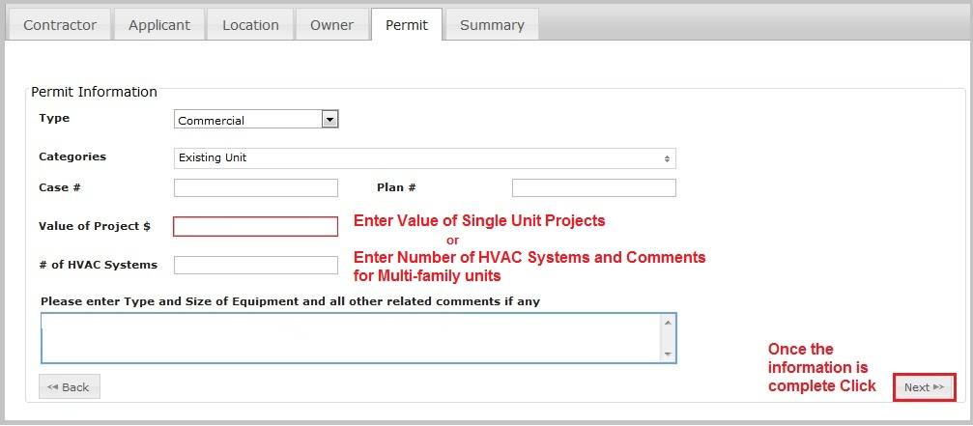
- For Residential Permits: Select one or more Categories from the drop down menu. Types include; Correction and Testing, Duplex, Existing Unit, Manufactured Home, Modular Building, New Construction and Other.
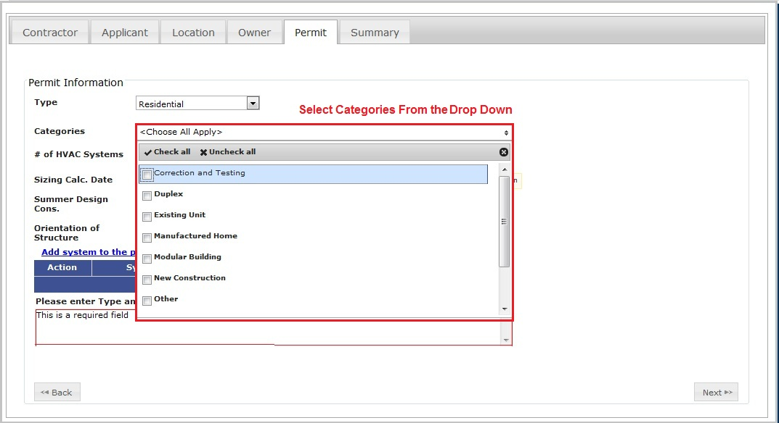
- You must enter a number value for the # of HVAC Systems. Click on the Add the system information to the permit application link to add a row to the Action/System/Sq. Foot/Heat Gain/Heat Loss grid.
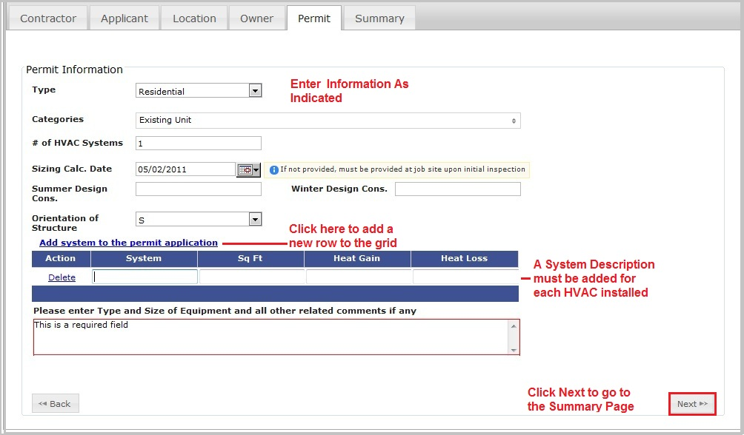

The Summary Tab-HVAC
After completing the Permit Category and Additional Required Information, click Next and a Summary of the Permit and the Calculated Permit Charges will display similar to the information found in the figure below. This form is used for both Residential and Commercial Summary information.
- If you did not complete all required fields during the application process, the system will display the appropriate error message and you will need to correct the error before proceeding to Check Out.
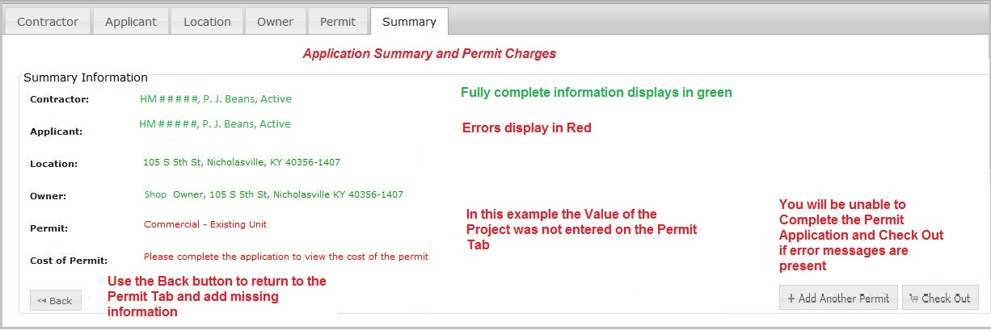
- The information that you have entered up to this point has been saved even if it is not yet complete. See the section on Viewing My Permits and Applications to learn more about Editing an incomplete Permit Application.
- If you want to add one or more Permit Applications prior to Check Out, select the +Add Another Permit button. If you would like to Check Out and pay the Permit Application fee for the Permit that you just entered, click on the Check Out button at the bottom right of the form. NOTE: If you want to pay for Multiple Permit Applications, please see the section on View My Permits and applications.
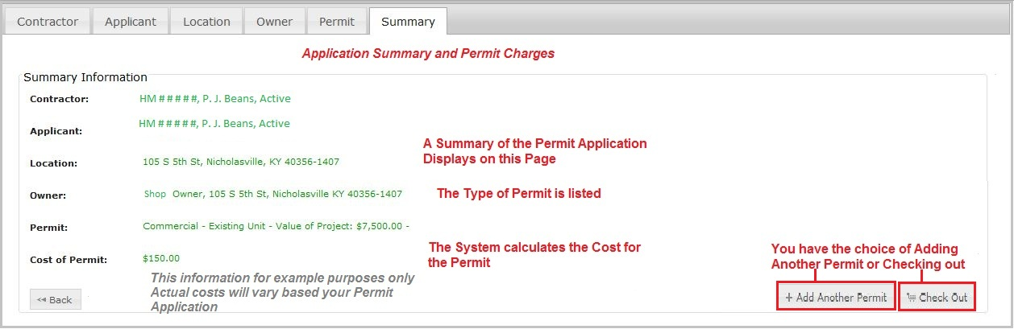

Entering Permit Applications for Plumbing
After logging in the system, additional choices based on your current license status are displayed in the Left Side Navigation Menu. If you are a Master plumbing Contractor with an Active license you will see all of choices shown below. If not, you will not see the Permit Application choices.
Please note: The eCommerce site accepts only Credit/Debit cards and eCheck payments. Contact KY DHBC to make other payment-type arrangements.
To begin the Application process select Apply for Plumbing Permit at the top of the Left Side Navigation Menu
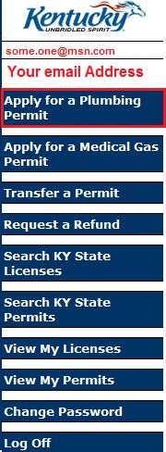

The Contractor Tab-Plumbing
Contractor Permit Applications are made in the license number of the Master Contractor for the project and the license must be in an active status.
- The following are users that can enter a permit application using the Master Contractor’s license number:
- A KY DHBC internal user enters a permit application into the system for the Master Contractor
- A person with system access; who is an employee of the Master Contractor on the project; enters the permit application for the project
- The Master Contractor him/herself enters the permit application
- There are two Checkbox options on the Contractor tab, Homeowner claiming exemption for licensure and Contractors. Only one can be selected.
- If Homeowner claiming exemption is chosen, click the Next button at the bottom right of the page to continue or select the Applicant Tab by clicking on Applicant at the top of the form.
- Master Contractors who are logged into the system will have their information displayed automatically on the Contractor tab.
- If you are not the Master Contractor, enter the Master Contractor License # and click on Verify Contractor Information. Information about the contractor, including addresses and license status displays under the License Number field.

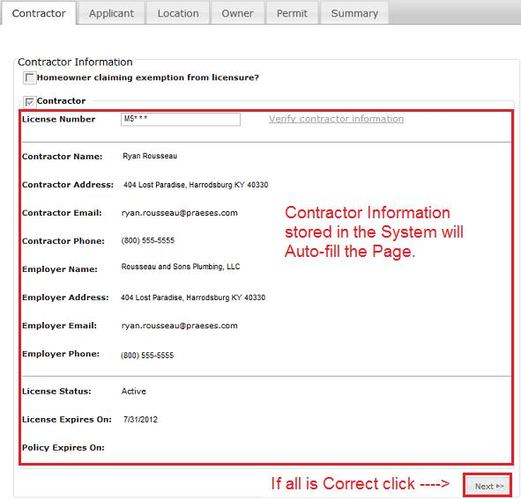
- After the contractor is verified, Click the Next button or Click on the Applicant Tab at the top of the form.

The Applicant Tab-Plumbing

- If the Contractor is the applicant select the top checkbox and click Next or click on the Location Tab at the top of the form. The applicant information for this application will be taken from the Contractor information already stored in the system.
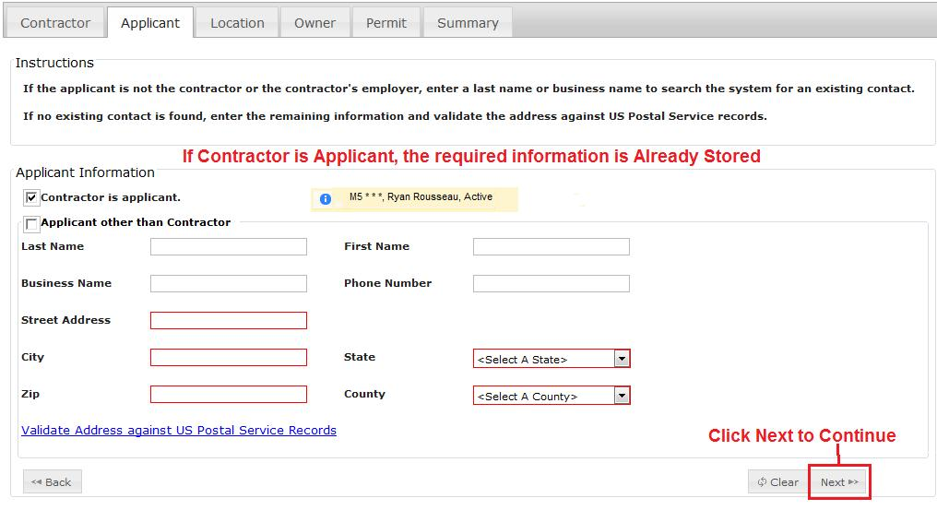
- If the Contractor is not the Applicant, check the Applicant other Than Contractor box and fill in the one of the following:
  - Enter the Last Name and press Enter. The system has an automatic search feature based on the Last Name, and will return all records found with a matching Last Name. This will help reduce the amount of data entry.
  - If the Applicant is a business, fill in the section for the Business Name and press Enter. The system also does an automatic search based on the Business name.

- If there are no matches by Last Names or Business Names, the grid will not display. The search will display the first 10 records. If more than 10 records are found, the number of records is displayed at the bottom right of the grid. If more than one page of records is found, you can use the right and left arrows to move through the pages to locate the desired record. NOTE: The arrows have been highlighted in red in the following figure. The arrows will be light gray on the bottom of the grid.
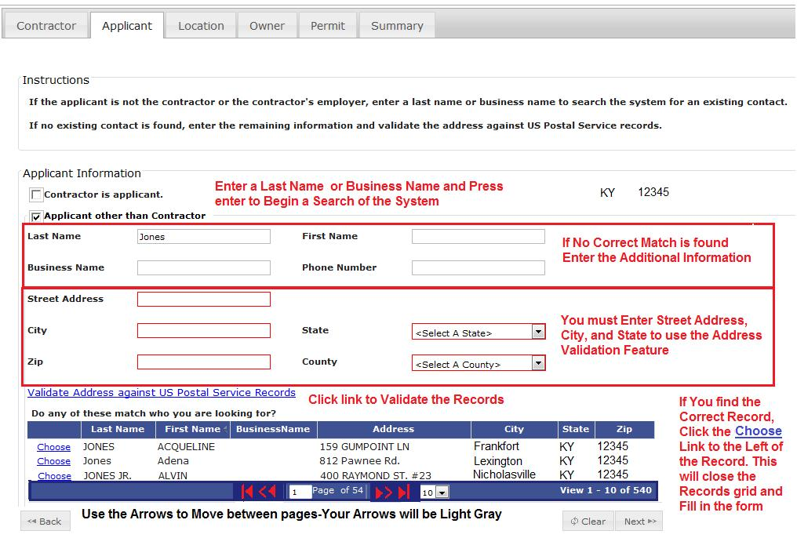
- If you determine that there is an identical record (Last Name, First Name, Address, City State and Zip) or (Business Name, Address, City, State and Zip) in the search results, click on the link Choose to the left of the record. The information will populate the form fields and the grid disappears as shown below. If the information is correct, click Next to continue. It is not necessary to validate an existing record and address against the US Postal Service Records. The system will use this data for the permit application.
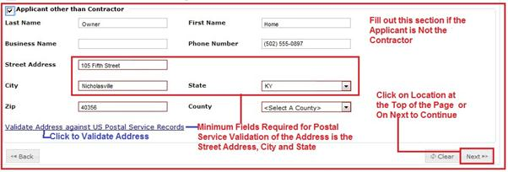
- If searching for the Last Name or Business Name did not produce any matching records, it will be necessary to enter data into the Applicant form. This new information will be used for this Permit Application and stored in the system for future reference.

- The Street Address, City and State must be filled in to use the US Postal Service validation link. After entering the information for these three fields, Click on the Validate Address against US Postal Service Records link on the screen and the form expands to display the standardized address
- Once you have determined that the Validated Address is the correct one to use, click on the Use the Validated Address link. This will update the fields in the Applicant form and hide the validated address box as shown below.
- Click Next to continue to the Location tab.

The Location Tab-Plumbing
The Location tab contains information about the physical address that the permitted Plumbing work will be accomplished. This tab also has an Address Validation feature. Instructions for data entry are located at the top of this tab as shown in the next figure.
- If you know the complete address of the location where the plumbing project will be done, enter the Street Address, City, and State.

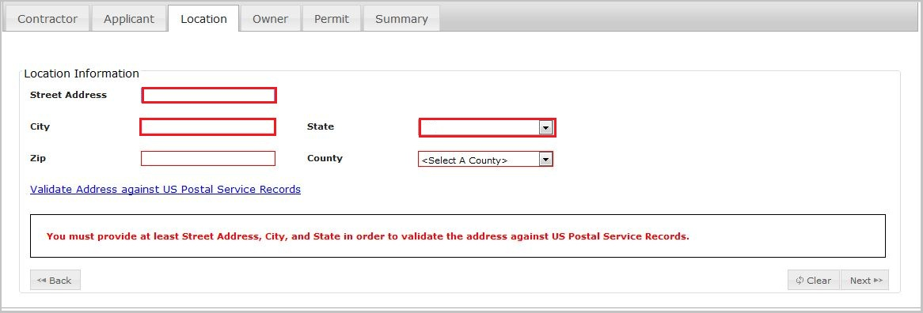
- Click the Validate Address against US Postal Service Records link.
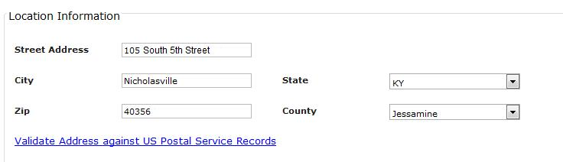
- If the system can validate the address to Postal Service records, a validated address will appear below the Information that you entered.
- If the address is also found in the system, a grid will display below that with the system information.
- Click Choose to select an address from the grid Or Click Use the Validated Address to use the Postal Service address
- The Grid and Validated address box are closed. Click Next to continue
- Don’t Remember the Exact Address or Spelling? You can enter a partial Street Address and the system will attempt to find a matching record (Shown in the next figure).
- Click the Validate Address against US Postal Service Records. Because the address is a partial address, the system will display a message “Unknown street, a match could not be found.” New construction sites are prone to this error
as the Postal Service often does not have the address in their database since no delivery point exists.
- If the address is not in the list, click on the Cannot find the Address in the list? Add as a new address link.
- After adding the new address use the Validate Address against US Postal Service Records link the Street Address, City and State; this is a required step.
- You can then determine which address to use, the one that was just entered into the system or the one that the Postal Service Records show as the standardized address for the location.
- You if you want to use the USPS Validated address just click on the Use the Validated Address and this will update the fields in the Applicant form and hide the validated address box.
- Once the location Address fields have been filled, Click on Next or the Owner tab to continue the Plumbing Permit Application.

The Owner Tab-Plumbing
This tab records the Owner information for the permit. There are three options.
- Click the appropriate checkbox. If the Applicant is the Owner is checked no further information is needed; click Next to continue
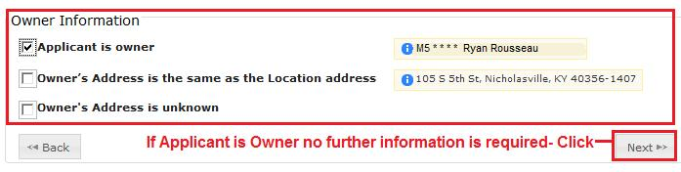
- If the Owner’s Address is the same as the Location Address is selected additional information is required. Enter the Business name and Phone number or the Last Name, First Name and Phone number of the owner. This information is required to continue to the Permit tab.
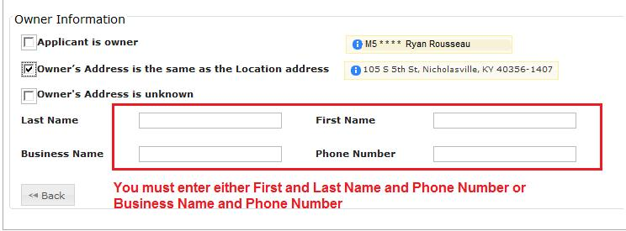
- If the Owner’s Address is unknown is selected additional information is also required. Enter the Business name and Phone number or the Last Name, First Name and Phone number of the owner.
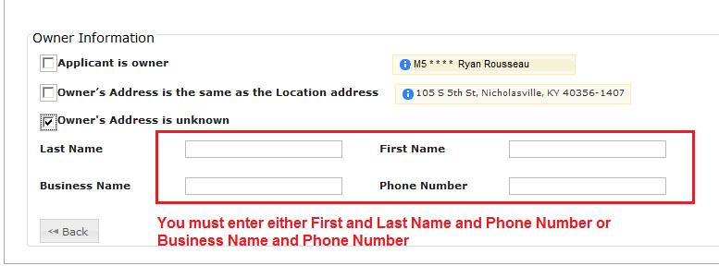

- Once the selection is made and any necessary information filled in, click Next to continue to the Permit tab.

The Permit Tab-Plumbing

Plumbing Permits for Purposes Other than “None of the Above”
- From the Type drop down – indicate if this is a Commercial or Residential Permit.
- Commercial and Residential Permits have the same purpose lists. The “None of the Above” Purpose type is discussed in the next Section
- This section covers these Purpose Types:
  - Water Heater Replacement Only
  - Water Service Only
  - Sewer Service Only
  - Sewer and Water Service Only; Back Flow Preventer Only
  - Lawn Irrigation Only
  - Mobile Home Park Only;
- Click on the drop down arrow to the right of the Purpose box. A list will display with Checkboxes to the left of each type or purpose.
- Choose the one that applies from the Purpose menu.
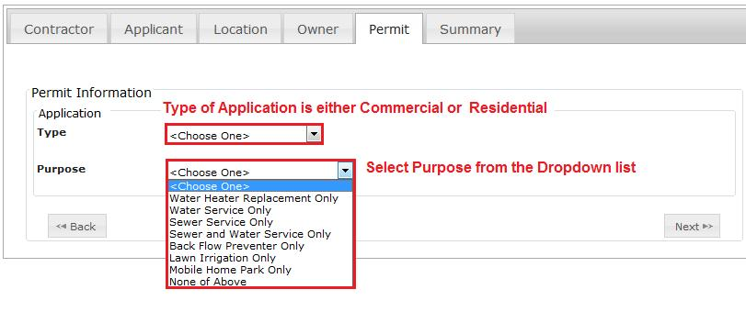
- If Water Heater Replacement Only, Back Flow Preventer Only or Mobile Home Park Only is selected, an additional information box will appear asking for the # (Number) of Units. Enter the number of units in this field as shown in the following figure.

- No additional information is required for Water Service Only, Sewer Service Only, Sewer and Water Service Only or Law Irrigation Only.
- Once you have filled in the Permit form click Next to go to the Summary tab.

Plumbing Permits for the Purpose “None of the Above”
The “None of the Above” purpose is used for Permits that are more complicated in nature, such as new construction or building remodeling which may multiple work projects or tasks for the same location. When “None of the Above” is selected as a Purpose, Additional information boxes are displayed as shown below.
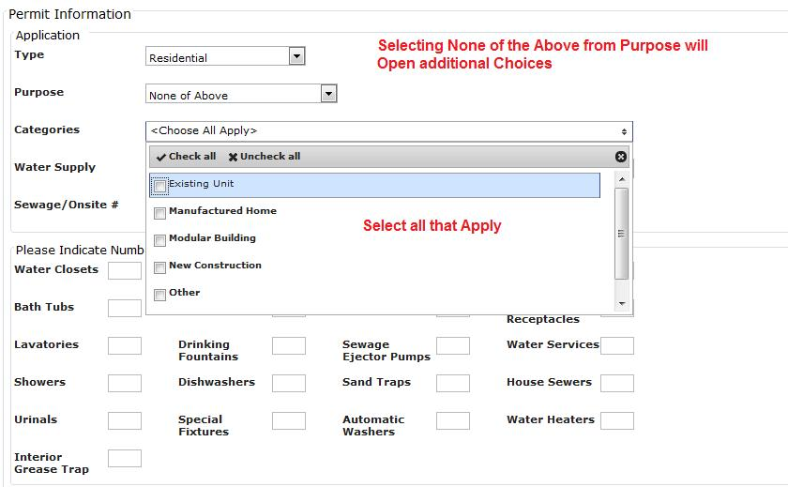
- Select one or more Categories from the drop down menu. Types include; Existing Unit, Manufactured Home, Modular Building, New Construction, Other and Single Family Unit.
- If the Type of Permit is Residential, these three fields appear under the categories box.
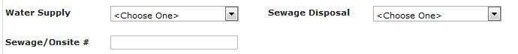
  - Use the drop downs to select the water supply source and sewage disposal method.
  - Enter the required Department of Health permit number in Sewage/Onsite #.
- If the Type of Permit is Commercial, these fields will display under the categories box.
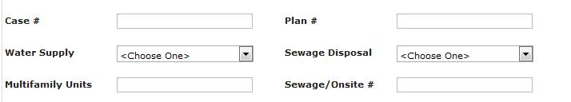
  - Commercial Permits require that the case and plan numbers be entered into the first two fields.
  - Use the drop downs to select the water supply source and sewage disposal method.
  - If Multifamily Unit was selected as a category you must enter a number for the Multifamily Units.
  - Enter the sewage permit number from the Department of Health.
- The number and type of Openings grid for both Commercial and Residential “None of the Above” Permits are as shown in the following figure. Enter the number of each type of opening in the box to the right of the description.
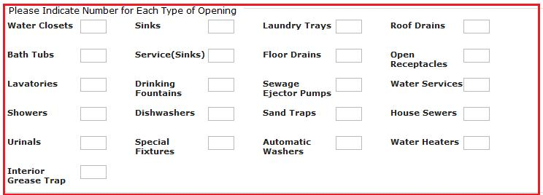
- Once all information about the permit is entered, click Next to go to the summary page.

The Summary Tab-Plumbing
After completing the Permit Category and Additional Required Information, Click Next and a Summary of the Permit and the Calculated Permit Charges will display similar to the information found in the next figure.
- The system calculates the plumbing permit charges based on the information that was entered into the Permit Tab.
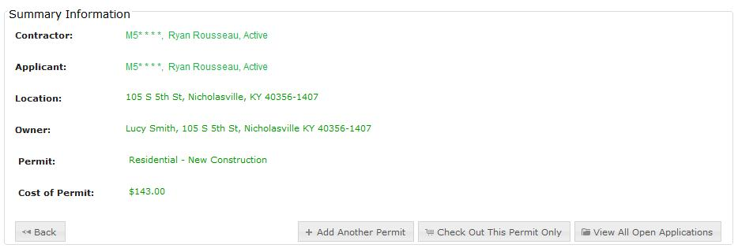
- The same Summary tab is used for both Residential and Commercial Summary information.
- The information that you have entered up to this point has been saved even if it is not yet complete.
- If all information displayed on the Summary Tab is correct (lettering will be green) you will have three Options:
  - Add Another Permit-This option allows you to enter another Plumbing Permit Application.
    - Saves the permit information just entered
    - Populates the Contract and Applicant Tabs with the same information used to create the previous Plumbing Permit Application
    - Clears the Location, Owner, Permit and Summary Tabs
    - Takes you back to the Location tab to begin entering the information on the new Permit.
  - Check Out this Permit Only-This Option
    - Takes you to the Check Out process
    - Allows you to pay for this permit only
  - View All Open Applications-This Option
    - Opens the View My Applications Grid so that you may select another permit application to edit

- If you did not complete all required fields during the application process, the system will display an error message that indicates the tab where the error occurred. The error message appears in red lettering.
- The error must be corrected before the system will display the Check Out This Permit Only button.
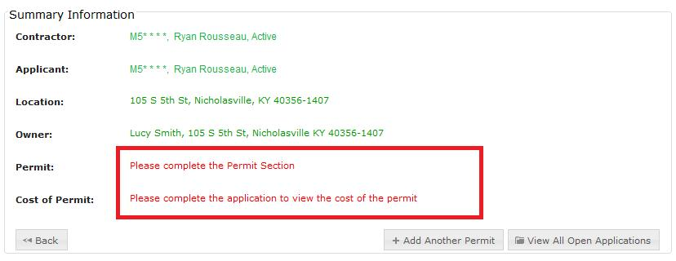
- Use the Back button or Click on the appropriate Tab (Contractor, Applicant, Location, Owner or Permit) at the top of the form to enter the missing information.
- If you choose not to correct the error, the application information entered to this point has been saved to the system. There are two option buttons in the lower right hand corner
  - Add Another Permit-This option
    - Saves the permit information just entered
    - Populates the Contract and Applicant Tabs with the same information used to create the previous Plumbing Permit Application
    - Clears the Location, Owner, Permit and Summary Tabs
    - Takes you back to the Location tab to begin entering the information on the new Permit.
  - View All Open Applications-This Option
    - Opens the View My Applications Grid so that you may select another permit application to edit

Entering an Application for a Medical Gas Permit-Plumbing
After logging in the system, additional choices based on your current license status are displayed in the Left Side Navigation Menu. Not all users will see all choices.
Please note: The eCommerce site accepts only Credit/Debit cards and eCheck payments. Contact KY DHBC to make other payment-type arrangements.
Click the Apply for Medical Gas Permit on the Left Side Navigation Menu to begin the Medical Gas Permit Process.
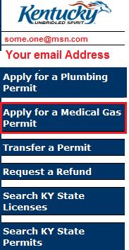

The Contractor Tab- Medical Gas Permit Applications
Medical Gas Permit Applications are made in the license number of the Master Contractor for the project and the license must be in an active status.
- The following are users that can enter a permit application using the Master Contractor’s license number:
- A KY DHBC internal user enters a permit application into the system for the Master Contractor
- A person with system access; who is an employee of the Master Contractor on the project; enters the permit application for the project
- The Master Contractor him/herself enters the permit application
- While there are two Checkbox options on the Contractor tab, the option for Homeowner claiming exemption for licensure is disabled and only Contactor can be selected.
- Master Contractors who are logged into the system will have their information displayed automatically on the Contractor tab.
- If you are not the Master Contractor, enter the Master Contractor License # and click on Verify Contractor Information. Information about the contractor, including addresses and license status displays under the License Number field.
- After the contractor is verified, Click the Next button or Click on the Applicant Tab at the top of the form.

The Applicant Tab- Medical Gas Permit Applications-Plumbing

- If the Contractor is the applicant select the top checkbox and click Next or click on the Location Tab at the top of the form. The applicant information for this application will be taken from the Contractor information already stored in the system.
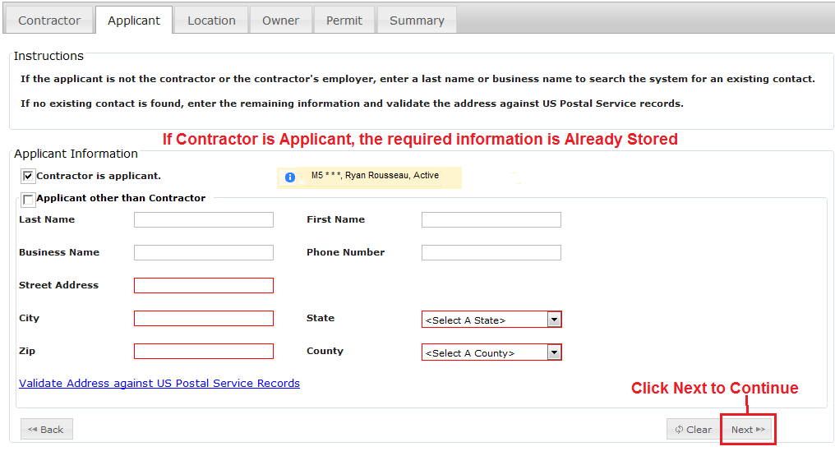
- If the Contractor is not the Applicant, check the Applicant other Than Contractor box and fill in the one of the following:
  - Enter the Last Name and press Enter. The system has an automatic search feature based on the Last Name, and will return all records found with a matching Last Name. This will help reduce the amount of data entry.
  - If the Applicant is a business, fill in the section for the Business Name and press Enter. The system also does an automatic search based on the Business name.

- If there are no matches by Last Names or Business Names, the grid will not display. The search will display the first 10 records. If more than 10 records are found, the number of records is displayed at the bottom right of the grid. If more than one page of records is found, you can use the right and left arrows to move through the pages to locate the desired record. NOTE: The arrows have been highlighted in red in the following figure. The arrows will be light gray on the bottom of the grid.
- If you determine that there is an identical record (Last Name, First Name, Address, City State and Zip) or (Business Name, Address, City, State and Zip) in the search results, click on the link Choose to the left of the record. The information will populate the form fields and the grid disappears as shown below. If the information is correct, click Next to continue. It is not necessary to validate an existing record and address against the US Postal Service Records. The system will use this data for the permit application.
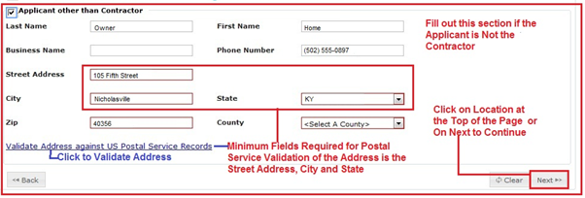
- If searching for the Last Name or Business Name did not produce any matching records, it will be necessary to enter data into the Applicant form. This new information will be used for this Permit Application and stored in the system for future reference.

- The Street Address, City and State must be filled in to use the US Postal Service validation link. After entering the information for these three fields, Click on the Validate Address against US Postal Service Records link on the screen and the form expands to display the standardized address
- Once you have determined that the Validated Address is the correct one to use, click on the Use the Validated Address link. This will update the fields in the Applicant form and hide the validated address box as shown below.
- Click Next to continue to the Location tab.

The Location Tab- Medical Gas Permit Applications-Plumbing
The Location tab contains information about the physical address that the permitted Plumbing work will be accomplished. This tab also has an Address Validation feature. Instructions for data entry are located at the top of this tab as shown in the next figure.

- If you know the complete address of the location where the plumbing project will be done, enter the Street Address, City, and State.

- Click the Validate Address against US Postal Service Records link.
- If the system can validate the address to Postal Service records, a validated address will appear below the Information that you entered.
- If the address is also found in the system, a grid will display below that with the system information.
- Click Choose to select an address from the grid Or Click Use the Validated Address to use the Postal Service address
- The Grid and Validated address box are closed. Click Next to continue
- Don’t Remember the Exact Address or Spelling? You can enter a partial Street Address and the system will attempt to find a matching record (Shown in the next figure).
- Click the Validate Address against US Postal Service Records. Because the address is a partial address, the system will display a message “Unknown street, a match could not be found.” New construction sites are prone to this error as the Postal Service often does not have the address in their database since no delivery point exists.
- The If the address is not in the list, click on the Cannot find the Address in the list? Add as a new address link.
- After adding the new address use the Validate Address against US Postal Service Records link the Street Address, City and State; this is a required step.
- You can then determine which address to use, the one that was just entered into the system or the one that the Postal Service Records show as the standardized address for the location.
- You if you want to use the USPS Validated address just click on the Use the Validated Address and this will update the fields in the Applicant form and hide the validated address box.
- Once the location Address fields have been filled, Click on Next or the Owner tab to continue the Plumbing Permit Application.

The Owner Tab - Medical Gas Permit Applications-Plumbing
This tab records the Owner information for the permit. There are three options.
- Click the appropriate checkbox. If the Applicant is the Owner is checked no further information is needed; click Next to continue
- If the Owner’s Address is the same as the Location Address is selected additional information is required. Because Medical Gas Permits are strictly commercial, you will need to enter the Business name and Phone number or the Last Name, First Name and Phone number of the owner. This information is required to continue to the Permit tab.
- If the Owner’s Address is unknown is selected additional information is also required. Again, because installation of these openings is limited to commercial property, you should enter the Business name and Phone number or the Last Name, First Name and Phone number of the owner.
- Once the selection is made and any necessary information filled in, click Next to continue to the Permit tab.

The Permit Tab - Medical Gas Permit Applications-Plumbing
- Permit Type automatically defaults to Commercial for Medical Gas Permit applications.
- Category choices are Existing Unit and New Construction
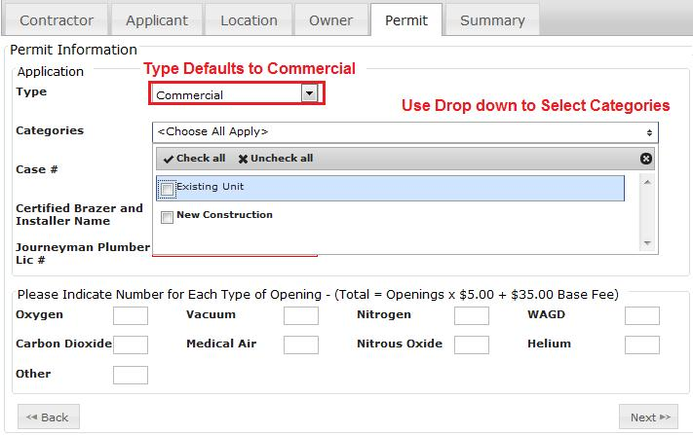
- Enter the Case # and Plan # for the project
- Enter the name of the Certified Brazer and Installer and his/her Journeyman Plumber Lic#
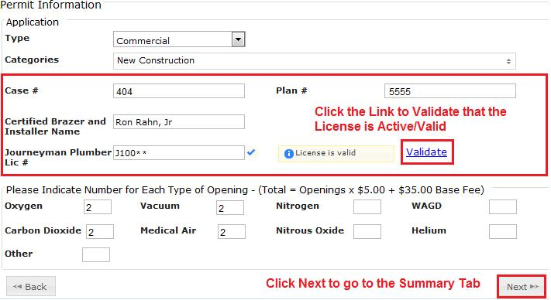
- It is necessary to validate the license number by clicking on the Validate link to the right of the License number.
- The system does not allow a Gas Permit Application to be filed with an invalid License number. If the License number that you are using causes an error message to display, try re-entering the number.
- If you are unsure of the number, please see Section 6 on Search KY State Licenses
- Indicate the number of each type of opening in the boxes to the right of the descriptions as shown in the previous figure.
- After all information is entered and validated, click the Next button to go to the Summary Tab.

The Summary Tab-Medical Gas Permit Applications-Plumbing
- The system calculates the Medical Gas Permit application charges based on the information that was entered into the Permit Tab.
- The information that you have entered up to this point has been saved even if it is not yet complete.
- If all information displayed on the Summary Tab is correct (all lettering will be green) you will have three Options:
  - Add Another Permit-This option
    - Saves the permit information just entered
    - Populates the Contract and Applicant Tabs with the same information used to create the previous Plumbing Permit Application
    - Clears the Location, Owner, Permit and Summary Tabs
    - Takes you back to the Location tab to begin entering the information on the new Permit.
  - Check Out this Permit Only-This Option
    - Takes you to the Check Out process
    - Allows you to pay for this permit only
  - View All Open Applications-This Option
    - Opens the View My Applications Grid so that you may select another permit application to edit

- If you did not complete all required fields during the application process, the system will display an error message that indicates the tab where the error occurred. The error message appears in red lettering.
- The error must be corrected before the system will display the Check Out This Permit Only button.
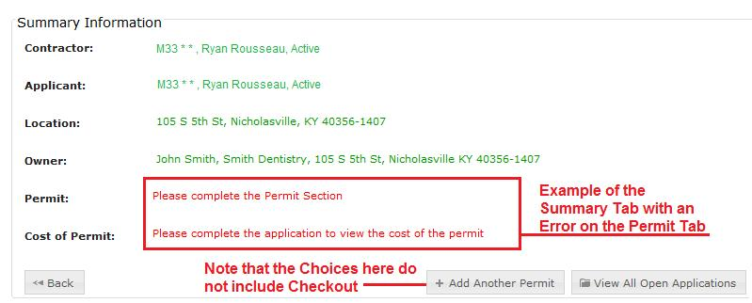
- Use the Back button or Click on the appropriate Tab (Contractor, Applicant, Location, Owner or Permit) at the top of the form to enter the missing information.
- If you choose not to correct the error, the application information entered to this point has been saved to the system. There are two option buttons in the lower right hand corner
  - Add Another Permit-This option allows you to enter another Permit Application of the Same type (Medical Gas)
    - Saves the permit information just entered
    - Populates the Contract and Applicant Tabs with the same information used to create the previous Medical Gas Permit Application
    - Clears the Location, Owner, Permit and Summary Tabs
    - Takes you back to the Location tab to begin entering the information on the new Permit.
  - View All Open Applications-This Option
    - Opens the View My Applications Grid so that you may select another permit application to edit

Homeowners Entering Plumbing Permit Applications

Beginning the Application Process
- After the Homeowner logs into the KY Portal, they will see the following screen.
  - If a plumbing permit application has been begun it will display under the “My Plumbing Applications” heading.
  - If a plumbing permit has been issued, it will display under the “My Permits” heading.
  - If either of these headings have records, the Apply for a Plumbing Permit option on the Left Side Navigation Menu will not be displayed.
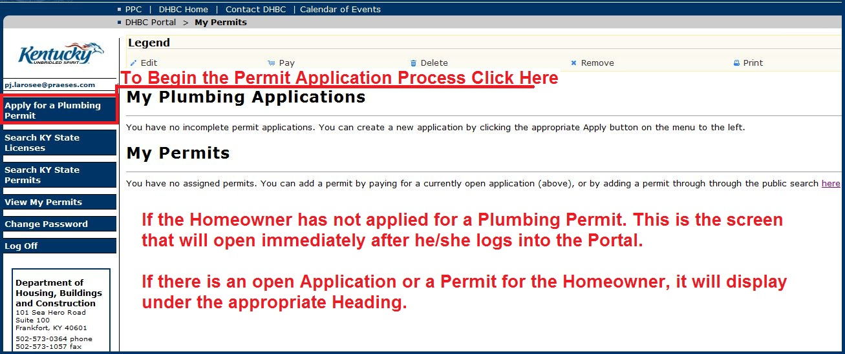

- To begin the application process, the Homeowner should click on the Apply for a Plumbing Permit button in the left side menu.
- Note: Once an application has been begun the data is saved even if the data is incomplete at the time that the user logs out or closes the browser menu.
- The Plumbing Contractor tab has been and Applicant tab have been prefilled.
  - The Plumbing Contractor has been checked as Homeowner claiming exemption from licensure?
  - The Applicant information has been prefilled from the Homeowner’s online registration information.
- The Permit Application tab menu opens with the Location Tab. Above the tab is a notice that all Homeowners should be encouraged to read and review. To open the notice, users can click on the link this important information.
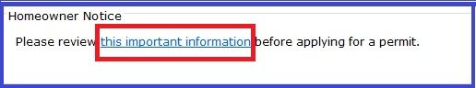
- The Homeowners Information Page opens in a new window and contains a great deal of information.
  - The left side (orange) contains clickable buttons for information from the Division of Plumbing
  - The center (red) has Alerts, Requirements and Regulations. The user can scroll down through all of the information by using the right side scroll bar.
  - The right side contains links to the required forms as well as contact information for homeowners to contact the DBHC directly.
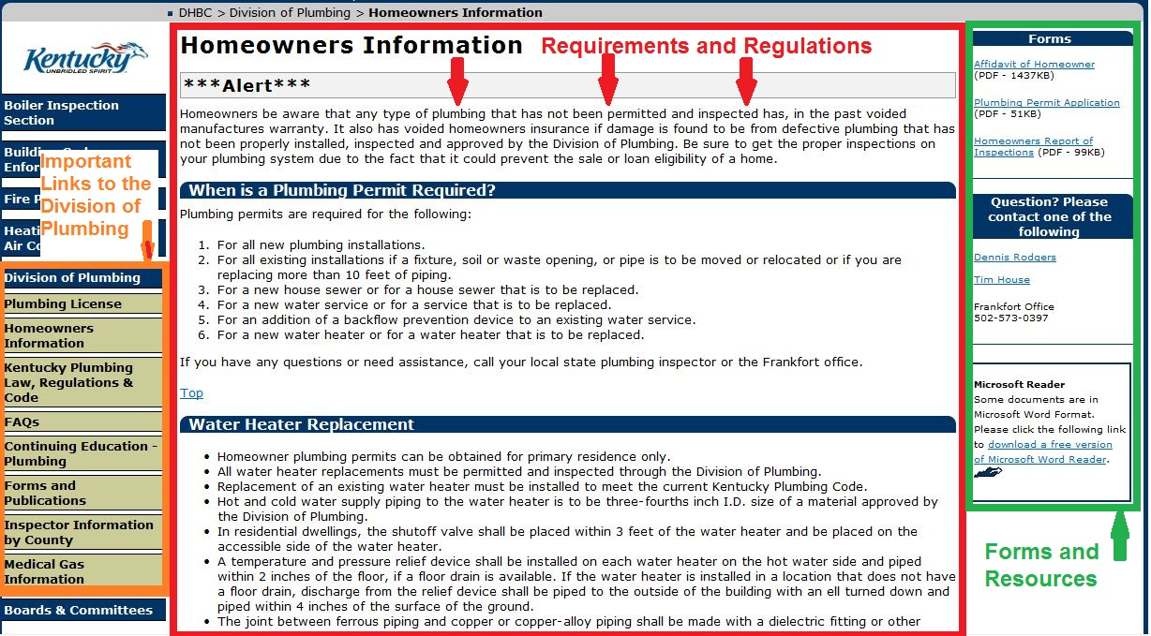
  - To close the window, click the [X] in the extreme upper right hand corner of the browser window.

Homeowner Location information
- Filling out the Location tab.
  - Instructions are found at the top of the page.
  - Enter the Street Address, City and Zip and select the County from the dropdown menu. The State is prefilled with KY.
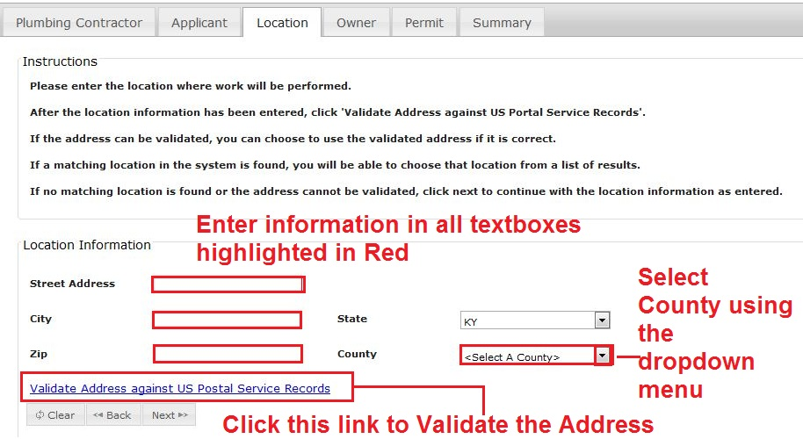
  - Click the Validate Address against US Postal Service Records
  - The system will search for the standard mailing address for the location that was entered. If one is found it will display below the Location Information as illustrated in the next figure.
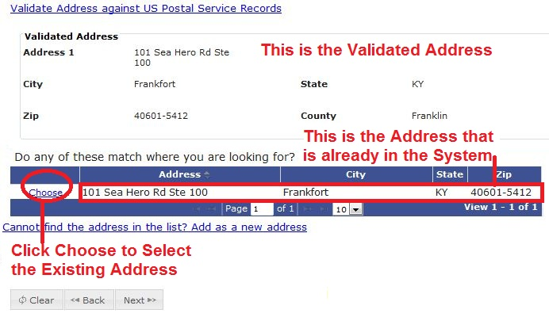
  - If the address is found in the system a message will appear listing addresses that match the one entered. Click the Choose link to the left of the address to select the one found in the system.
  - If the address is not in the system but it can be validated against the Postal Service records as a residential address, the user will see the Validated Address with a Use the Validated Address link below the zip code. Click this link to accept the validate address.
  - Then click the Next button at the bottom of the tab to continue.

The Homeowner Owner Tab
The Owner tab will display the owner’s address as registered in the system and the location address entered on the location page. They should match in all cases with the possible exception of new construction, where the owner is residing at the registered address and the location address is new.
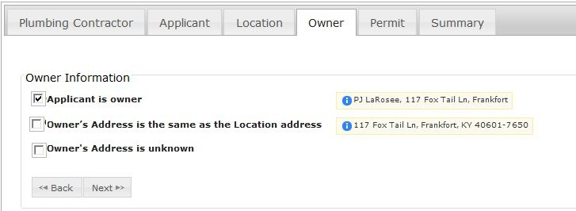

The Homeowner Permits Tab
Plumbing Permits for Purposes Other than “None of the Above”
- From the Type drop down – indicate if that this is a Residential Permit.
- This section covers these Purpose Types:
  - Water Heater Replacement Only
  - Water Service Only
  - Sewer Service Only
  - Sewer and Water Service Only; Back Flow Preventer Only
  - Lawn Irrigation Only
  - Mobile Home Park Only;
- Click on the drop down arrow to the right of the Purpose box. A list will display with Checkboxes to the left of each type or purpose.
- Choose the one that applies from the Purpose menu.
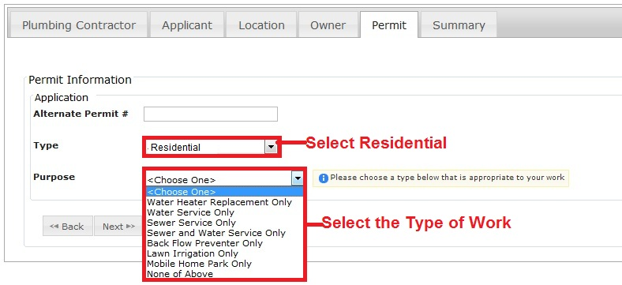
- If Water Heater Replacement Only, Back Flow Preventer Only or Mobile Home Park Only is selected, an additional information box will appear asking for the # (Number) of Units. Enter the number of units in this field as shown in the following figure.

- No additional information is required for Water Service Only, Sewer Service Only, Sewer and Water Service Only or Law Irrigation Only.
- Once you have filled in the Permit form click Next to go to the Summary tab.
Plumbing Permits for the Purpose “None of the Above”
The “None of the Above” purpose is used for Permits that are more complicated in nature, such as new construction or building remodeling which may multiple work projects or tasks for the same location. When “None of the Above” is selected as a Purpose, Additional information boxes are displayed as shown below.
- Select one or more Categories from the drop down menu. Types include; Existing Unit, Manufactured Home, Modular Building, New Construction, Other and Single Family Unit.
- Since the Type of Permit is Residential, these three fields appear under the categories box.
  - Use the drop downs to select the water supply source and sewage disposal method.
  - For New sewage connections, enter the required Department of Health permit number in Sewage/Onsite #.
- The number and type of Openings grid for Residential “None of the Above” Permits are as shown in the following figure. Enter the number of each type of opening in the box to the right of the description. The example below is for an existing home where the homeowner is adding a Master bathroom. The new addition will tie into the existing sewer system, water sources and water heater.
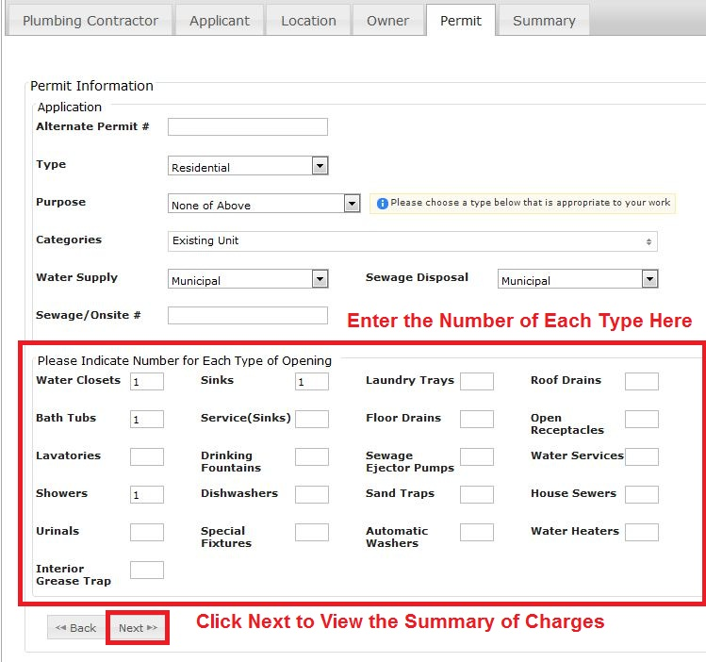
- Once all information about the permit is entered, click the Next button to go to the Summary tab.

The Homeowner Summary Page
This page lists the important details of the permit and displays the cost of the permit as calculated by the system based on the information entered.
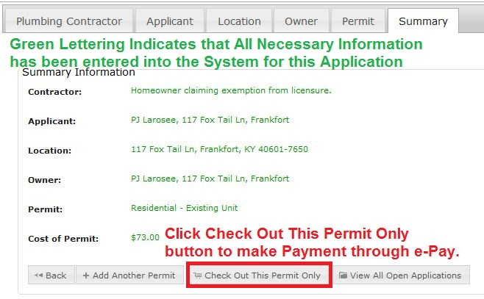
- All green lettering indicates that the information is complete.
- If any section was skipped or if data was left out, the lettering would appear in red. In that event, return to the tab (left) where the red lettering appears to the right and correct the information.
- Homeowners are limited to one permit/application so they should click the Check Out This Permit Only button to make an electronic payment.
- Homeowners will use the same check out process as contractors.

Check Out and Payment –All Users
- The Check Out Page lists the Permit Application or Applications that you have selected for payment. Each Permit Application summary and permit fees are separated by horizontal lines. The total due is listed at the right below the Permit Application Summaries.
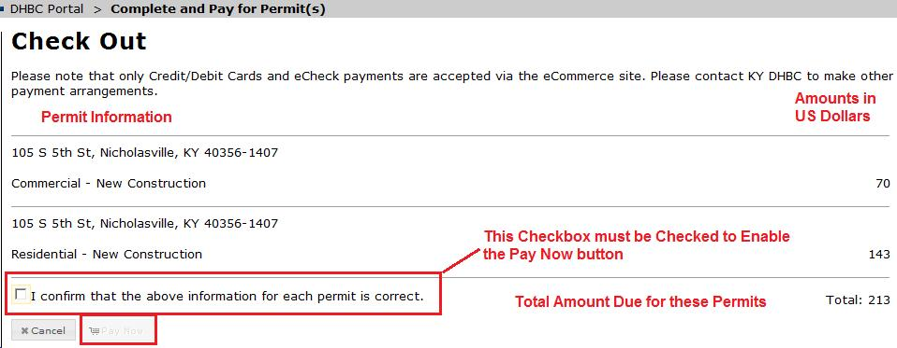
- To enable the Pay Now button you must first click the check box to the left of the statement “I confirm that the above information for each permit is correct.” To continue with the payment, Click Pay Now. To Cancel the Check Out and Payment process Click Cancel.
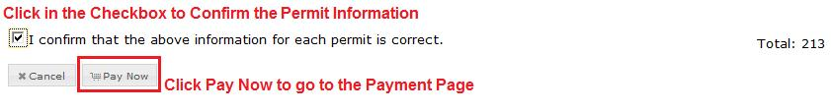
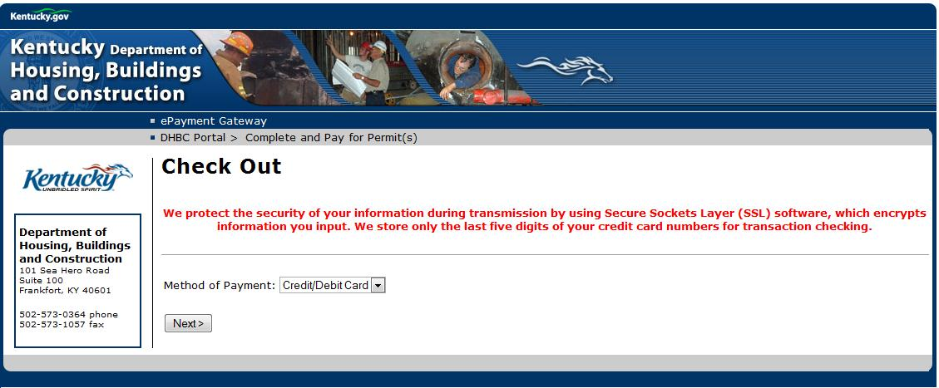
- The KY Portal automatically redirects you the State of Kentucky’s ePayment Gateway.
- Please note the security message on the Check Out page. To help ensure the security of your information, all information is encrypted before it is transmitted to the accounting systems. Only the last 5 digits of the credit card number are stored for transaction checking.
- Select the type of payment, either Credit/Debit or Check. NOTE: All Debit cards transactions are treated the same as Credit Card transactions for payment purposes.
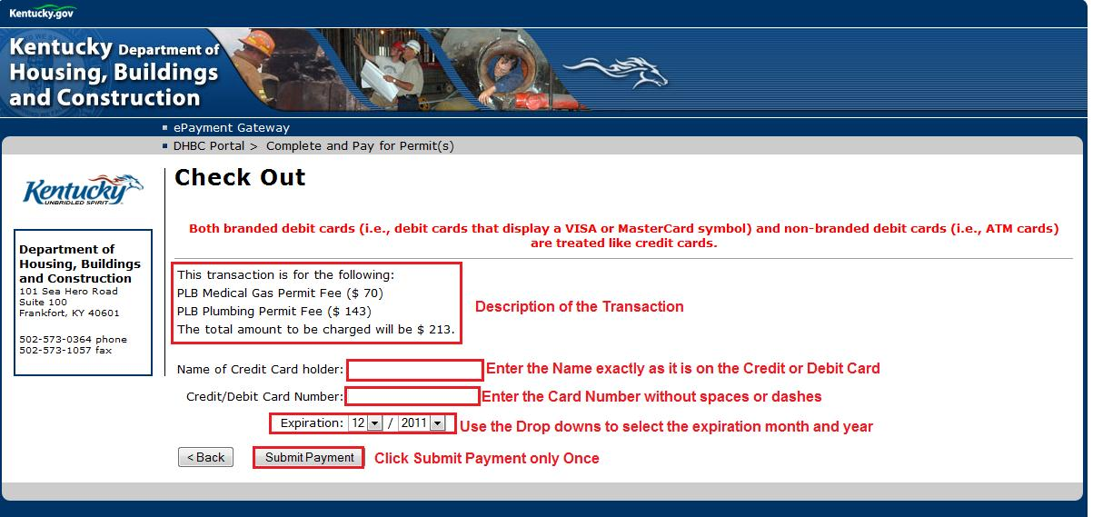
- For Credit Card/Debit Card payments:
  - Enter the Name of the Credit Card holder exactly as it is displayed on the credit/debit card.
  - Enter the Credit/Debit Card Number without spaces.
  - Select the month and year that the Card expires from the drop downs next to Expiration.
  - Click Submit Payment Only Once.
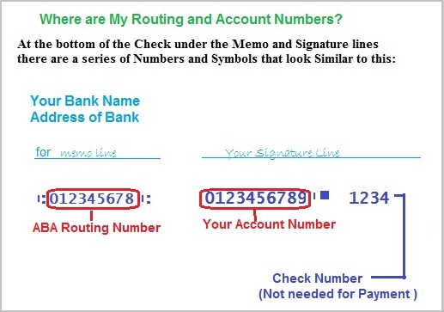

- To Make a Payment with an E-check your will need to have your Routing number and your Account number which are printed on the bottom of your checks or preprinted deposit slips.
  - The E-Check form will display as in the next figure. Enter the Name in the Name block. It must be in the Name of the Person or Business holding the account.
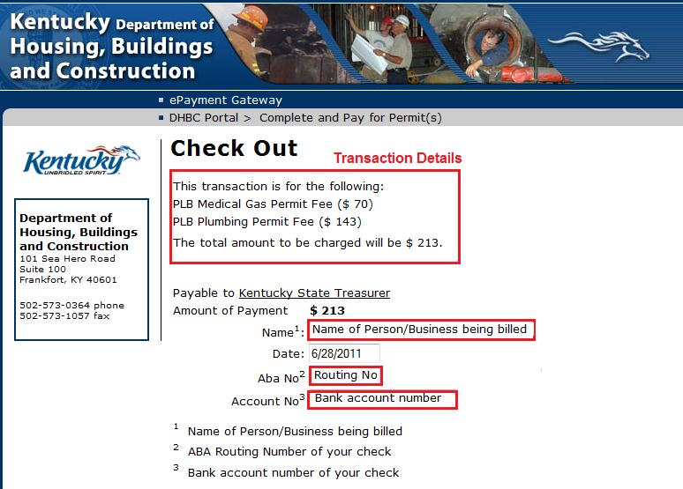
  - Click in the ABA No2 box and enter the routing number for your bank. Click the Account No³ and enter your account number. No Check number is needed for this type of payment.
  - Click Submit Payment Only Once
- The ePayment Gateway will process the payment and return you to the KY DHBC Portal.
- A summary of the Process Payment and Permit(s) will display.

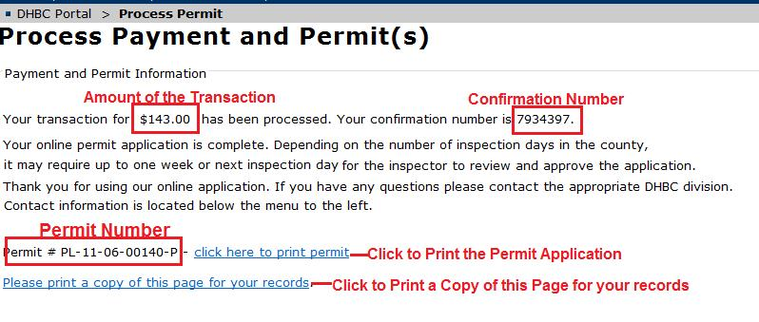
- The transaction amount, a confirmation number and the Permit number are listed on the screen.
- Use the link click here to print permit (found to right of the Permit number) to print a copy of the permit.
- You are strongly encouraged to use the Please Print a copy of this page for your records link in case a question arises about this transaction.
- After completing all the work that you want to accomplish, please remember to click the Log Off Button at the bottom of the Left Side Navigation Menu to make sure that you are completely and securely logged out of the KY DHBC Portal.

Search KY State Licenses-All Users
- To Search for a License for Contractors in the State of Kentucky, Click on Search KY State Licenses in the Left Side Navigation Menu.
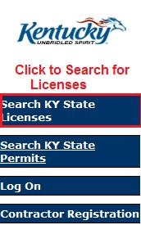
- The exact position of the Search KY State Licenses in the left menu will depend on your own role and permissions in the system.
- There are four types of Search Criteria; License Type, License Number, First Name (of the contractor) and Last Name (of the Contractor.) You can search by one or more fields.
- Depending on the Search Criteria entered it may take a few seconds for the System to locate the records. A Processing…. Message will display. Your results will display momentarily.
- The License Type is a drop down menu with specific types of licenses contractors are eligible for in Kentucky and is shown in the next figure To select a specific type, use the right scroll button to move through the list.
- Either Click in the desired check box (es) or Click the Check All at the top of the drop down. .
- If you Check All under License Type and do not enter other Search Criteria, the Search will return all Licenses for the State of Kentucky. You will be able to page through the hundreds of returned records to find the desired Contractor and License information, but it will be time consuming.
- For the best possible result, you are encouraged to use more than one Search Criteria.

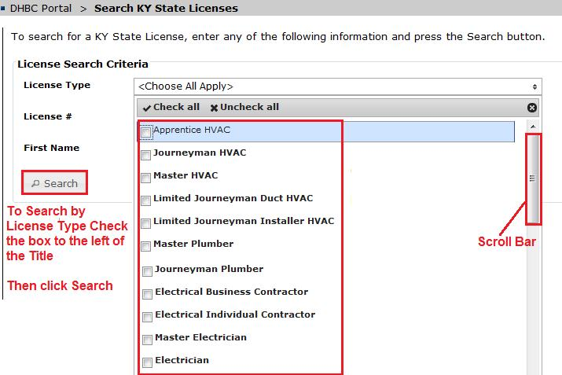
- After making your selection on License Type you can enter other values into the other Search fields. After all of the criteria is entered. Click the Search button. In the example that follows the License Type is “Master HVAC” and the First Name is “Jeff”. This combination of returns 69 records.
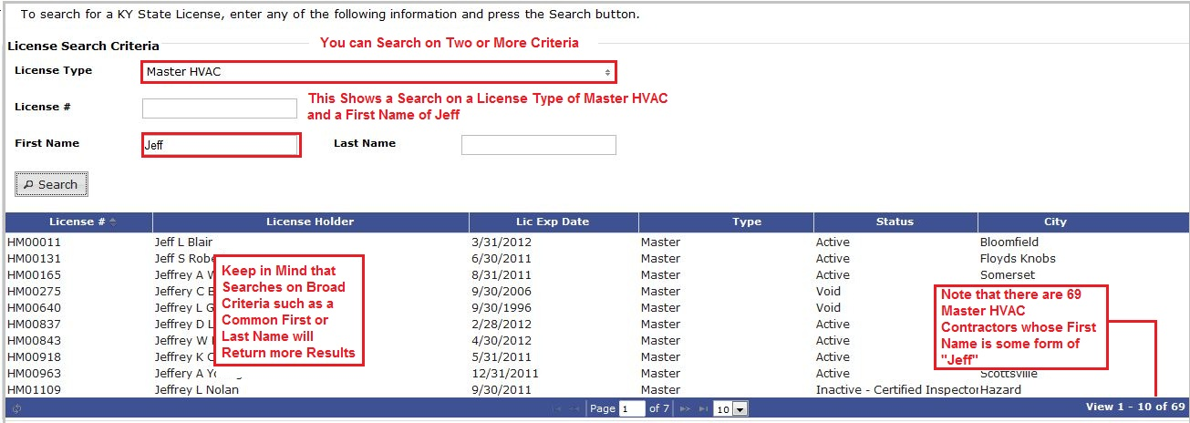
- In the next example, a combination of License Type, First Name and Last Name are used to find a License. Note that you can use a Partial Name in the First Name (Jeff) and Last Name (S) fields.
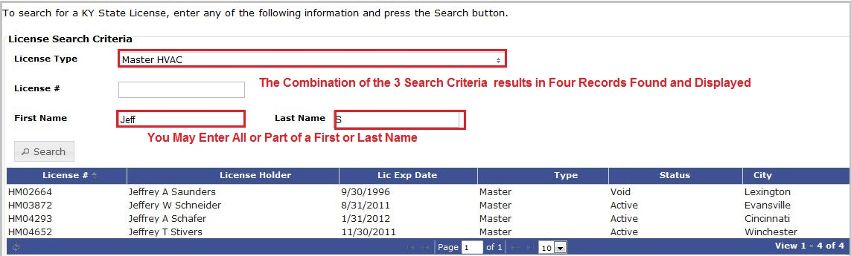
- The most specific Search Criteria is to Search on the Contractor’s License # (number). After Clicking Search, the Contractor information is displayed at the bottom of the form.
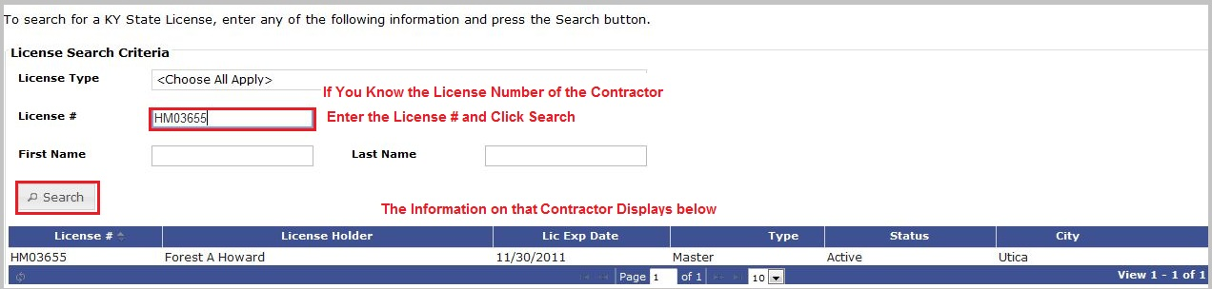

Search KY State Permits-All Users
- To Search for a Permit in the State of Kentucky, Click on Search KY State Permits in the Left Side Navigation Menu
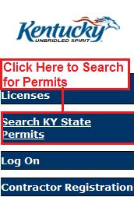
- The position of the Search KY State Permits will depend on your role and permissions in the system.
- If you know the permit number you can enter just that value into the Permit Number field, and Click the Search button.
- Depending on the Search Criteria entered it may take a few seconds for the System to locate the records. A Processing…. Message will display. Your results will display momentarily.
- The Permit record will display at the bottom of the form.
- There are three other possible Search Criteria; County, Street Address, and City
- County is a drop down menu of all the Counties in the State of Kentucky. Only 1 County can be selected as a Search Criteria at a time.
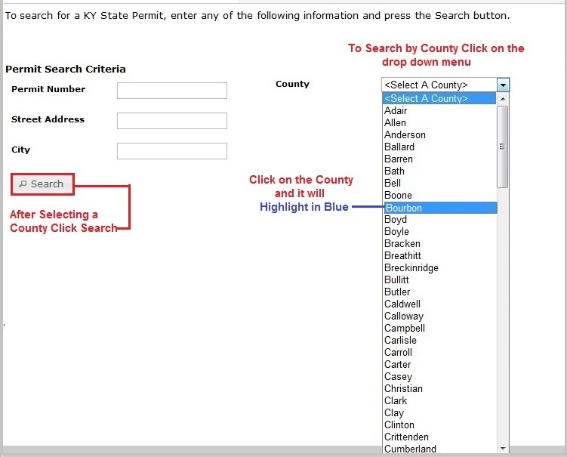
- When Searching for Permits to add to your list of Permits on the View My Permits page, you may elect to Search by City. This is illustrated in the next figure.
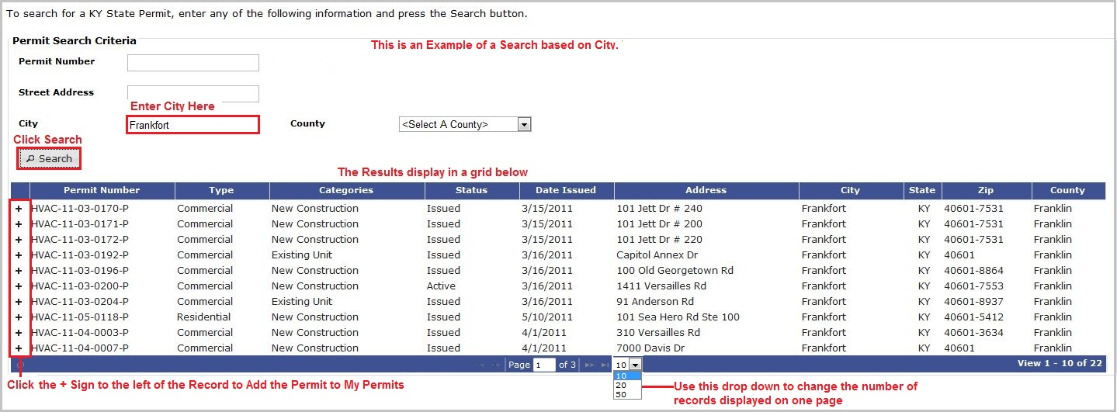
- To Add a Permit to My Permits, Click on the Plus Sign + to the left of the Permit Number.
- Street Address accepts partial address values as shown below. This is especially helpful when looking for a Permit where information is somewhat limited.
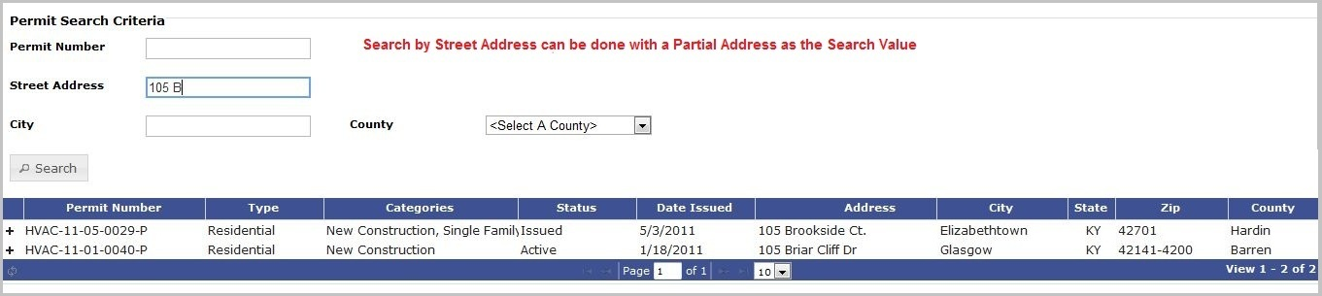
- If no records are returned, try broadening your Search Criteria by using City, County or a shorter Partial Address. In the example above, using “105 B” as a Street Address value resulted in 2 records being found and displayed. If the Street Address is shortened to “105”, the same Search would have 14 records displayed, and if the Street Address is shortened to “10” the system would locate 121 records.

Search KY State Plan Reviews-All Users
Plan reviews are required for some types of construction and plumbing projects and are part of the critical first steps in the construction process. To check on the progress of the plan review process for your project, do the following:
- Open the DHBC Portal and click on the link “ Search KY State Plan Reviews” in the left side navigation menu. The Search Criteria form will display as shown below
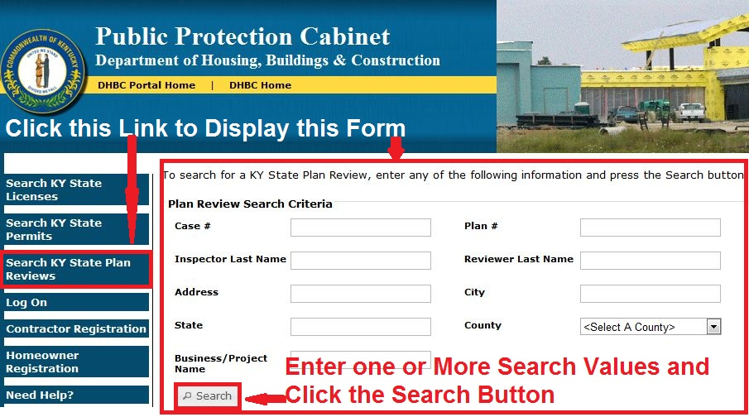

- For the fastest search, use the Case #. The next fastest search values are to enter the Address, City, State and County or the Business/Project Name. You can also search by Reviewer or Inspector Last Name. If you search only by Reviewer or Inspector last name the search will take longer due to the large number of plan reviews that any one inspector or reviewer can be associated with at one time.
- The details form appears allowing you to review the current status of the plan reviews for your project
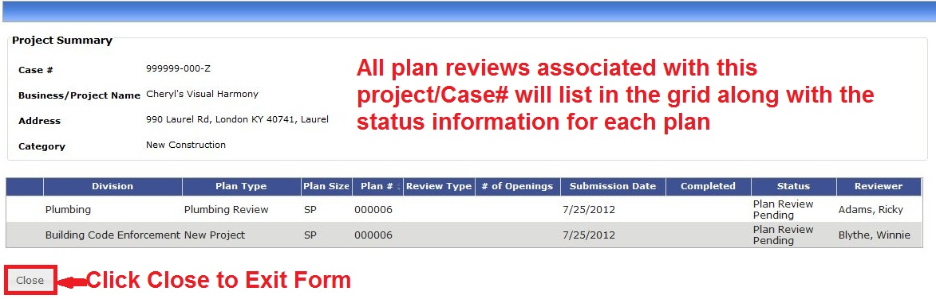
- Click close to exit

Transfer a Permit-Plumbing

The KY DBHC Portal allows plumbing permits to be transferred from another permit owner to you. To transfer a plumbing permit from the current owner to yourself, follow these steps:
- If you know the permit number, enter it into the Permit Number box and click the Search Button.
- You may also search using the First Name and Last Name of the current owner.
- Partial Values also may be entered as search criteria in one or more of the search fields as shown in the next figure. For additional information on searches, please click here.

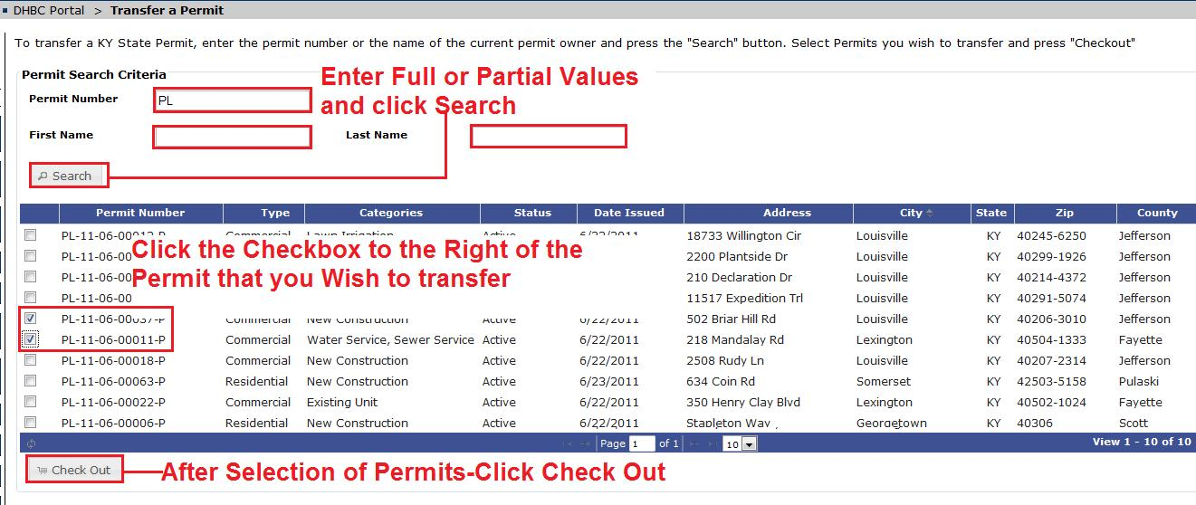
- After you have selected all of the permits that you wish to move, click the Check Out button under the grid.
- The Check Out page for Permit Transfer will display with the information about the permits that are being transferred to your account.
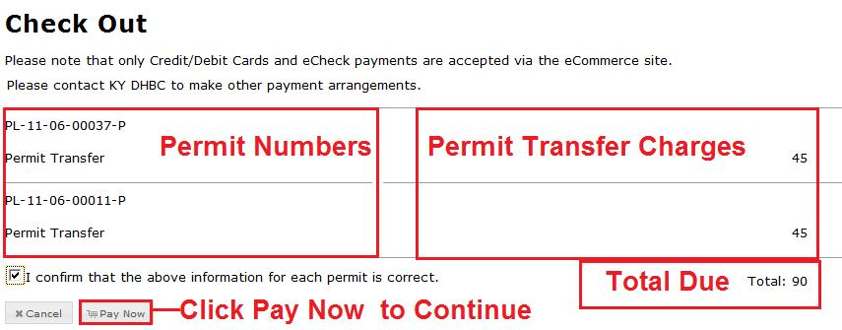
- You must click the Checkbox next to the Statement “I confirm that the above information for each permit is correct.” This action makes the Pay Now button available.
- Click the Pay Now button and you will be transferred to the KY ePayment Gateway. Payment choices are Credit/Debit Card or Check.
- Additional information on completing your payment is found in Section 8-Check Out and Payment. Click here to go to this section.
- After the payment process is complete, you can click on View My Permits to see the permits added to your list of permits.

Request a Refund-Plumbing
To request a refund for a plumbing permit, click on the Request a Refund button on the Left Side Navigation Menu.
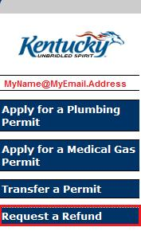
This will open an e-mail form pre-addressed to the personnel at KY DHBC who are responsible for handling plumbing refund requests.
To receive a refund for other trades (i.e. HVAC), please use the contact information for the division found at the bottom of the Left Side Navigation Menu.

